

UNDERSTANDING DISEASE TRENDS AND CLINICAL RESEARCH: A COMPREHENSIVE ANALYSIS

--



# AUTHORS:

MICHELLE JULIET

BENEDITA KAMAU

GLORYANN AJUANG’

# ABSTRACT:

This research paper provides a comprehensive analysis of clinical data encompassing various medical studies. The analysis covers COVID-19, heart disease, malaria, Pneumonia, Cancer and HIV studies. It examines key trends, outcomes, interventions, sponsors, and more. The paper presents valuable insights into the state of medical research, revealing trends and areas of focus, and offering recommendations for future research directions.

## INTRODUCTION

The field of clinical research plays a pivotal role in advancing medical knowledge, shaping healthcare policies, and ultimately improving patient outcomes. Clinical data analysis is instrumental in understanding disease trends, identifying effective treatments, and exploring new research avenues. In this research paper, we embark on a comprehensive journey through the clinical data landscape, with a focus on six major disease categories: COVID-19, heart disease, malaria, pneumonia, cancer and HIV. Our analysis aims to unveil critical insights into disease trends, outcomes, interventions, collaboration networks, and sponsors across these diverse areas of medical research.

Each of these diseases presents unique challenges, demanding tailored approaches and intervention strategies. COVID-19 has had a profound impact on global health, necessitating rapid research responses. Heart disease continues to be a leading cause of mortality worldwide, demanding ongoing investigation. Malaria remains a significant public health issue in many parts of the world, while HIV research has been instrumental in changing the course of the epidemic. Understanding the evolving landscape of clinical research in these domains is essential for optimizing healthcare strategies and addressing current and emerging health challenges.

Our research paper offers an in-depth analysis of temporal trends, outcome measures, publication patterns, interventions, adverse events, collaboration networks, sponsorship trends, and more, providing valuable insights for researchers, policymakers, and healthcare practitioners. Through this analysis, we aim to enhance our understanding of the clinical research landscape, identify research gaps, and provide recommendations for future research directions.

## PROBLEM STATEMENT

With an increasing volume of clinical data being generated, researchers and healthcare stakeholders face the challenge of navigating this vast landscape effectively. Consequently, the overarching problem statement is:

"How can we gain a holistic understanding of the clinical research landscape in the domains of COVID-19, heart disease, malaria, pneumonia, cancer and HIV, and how can this understanding inform future research, policy decisions, and healthcare practices?"

This research paper addresses this problem by providing a comprehensive analysis of clinical data across these disease categories, offering insights and recommendations for the scientific community, healthcare providers, and policymakers.

## METHODOLOGY

This section outlines the data sources, collection methods, and data analysis techniques used in the study. It clarifies how the clinical data was gathered and processed for analysis, including data cleaning, transformation, and statistical methods employed.

### DATA SOURCES

The clinical data used for this analysis were sourced from publicly available clinical trial databases, including ClinicalTrials.gov and additional sources specific to each disease category. We extracted information on a wide range of variables, including study start dates, phases, outcome measures, interventions, collaboration networks, sponsorship, and more.

### DATA PREPROCESSING

Data pre-processing was a crucial step in ensuring data accuracy and consistency. We conducted data cleaning, which included addressing missing values. Further, data transformation was applied to categorize and group data for analysis.

### DATA ANALYSIS

We employed a mix of descriptive statistics, data visualization, and statistical analysis to explore the clinical data. Descriptive statistics helped us understand the distribution of variables, while data visualization provided clear representations of trends over time and across different disease categories. Statistical tests were conducted to identify significant differences and correlations within the data.

#### TEMPORAL TRENDS ANALYSIS

Temporal trends refer to patterns, changes, or variations in data over time. In our analysis, we will see the pattern of covid-19 studies, HIV studies, Pneumonia studies etc. over time till our recent year.

- **COVID-19 Temporal Trends**

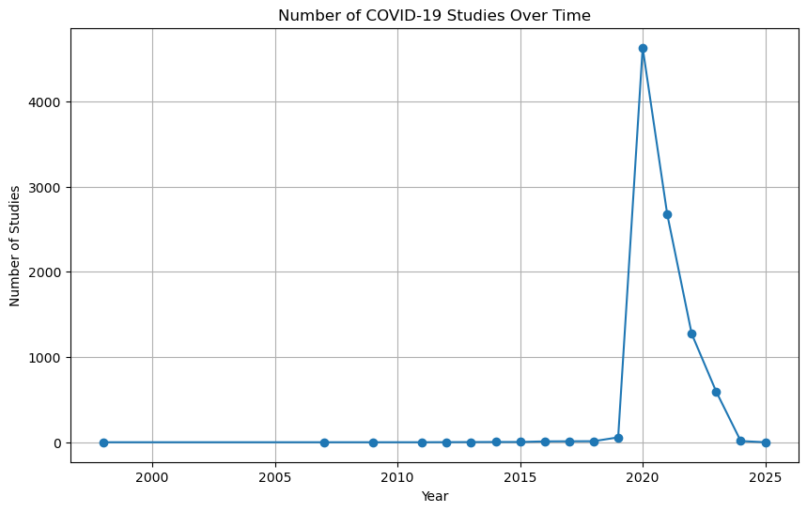

In the early years, **from 1998 to 2011, there were very few clinical studies related to COVID-19**, indicating that it was not a prominent area of research during this period. The number of studies **started to increase gradually from 2012, with a noticeable uptick in 2016 and 2017, possibly driven by emerging public health concerns related to COVID-19**. A significant increase in research activities is observed from 2019 onwards, with 58 studies initiated that year. This rise can be attributed to the emergence of COVID-19 as a global pandemic. **The year 2020 saw a substantial surge in COVID-19-related clinical studies, with 4,631 new studies initiated.** This corresponds with the urgent need for research on treatments, vaccines, and healthcare protocols in response to the pandemic**. In 2021, the number of studies remained high, with 2,679 new studies initiated, reflecting the sustained research efforts in understanding and managing the pandemic.** In 2022, while the number of studies decreased compared to the previous years, 1,273 new studies indicate ongoing research in the field. In 2023, the downward trend continued, with 595 new studies. This might suggest a gradual shift in research focus or the maturation of existing studies. 2024, the number of new studies further reduced, with only 15 initiated. This decrease could be attributed to the consolidation of existing research and a potential shift towards analyzing and publishing findings.

- **Heart Disease Temporal Trends**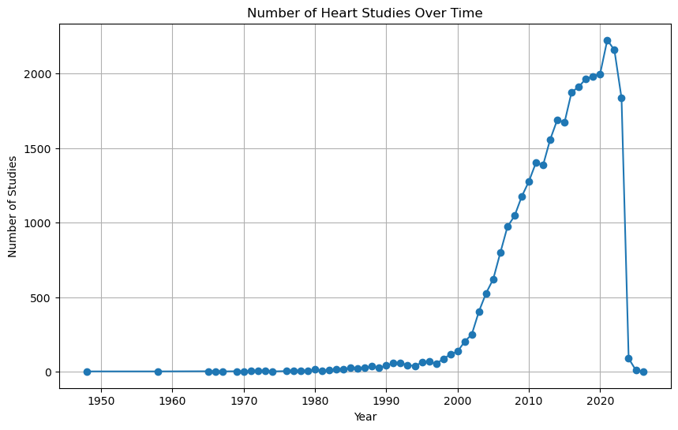

**2000s**: A significant uptick in the number of studies started can be observed in the early 2000s. This may coincide with increased awareness of heart-related health issues and research funding directed towards cardiovascular diseases.

**2010s**: The trend continues upward, with a notable increase in the number of studies throughout the 2010s. Advances in cardiology, healthcare technology, and a better understanding of heart diseases likely contributed to this growth.

**2020-2025: The most significant surge in heart studies is observed from 2020 to 2022**, with the number of studies initiated during these years surpassing previous decades. This surge is likely a response to the global health challenges posed by cardiovascular diseases and the need for improved treatments and interventions.

### Interpretation:

This trend reflects the increasing importance of cardiovascular research and the need for innovative solutions to address heart-related health issues. The data highlights the commitment of the scientific and medical community to improving heart health and reducing the burden of heart diseases.

**- Malaria Temporal Trends**

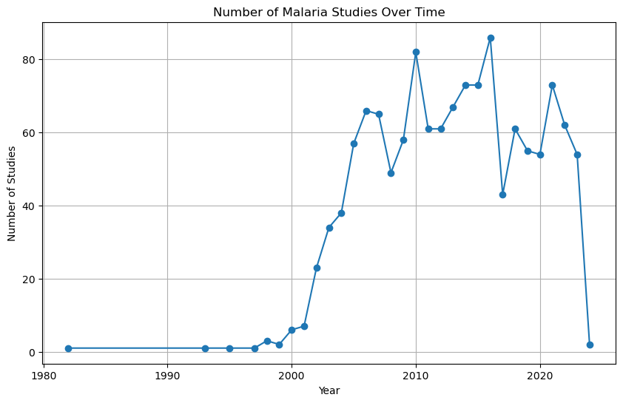

The number of malaria studies gradually increased, with variations, until reaching **the highest point in 2016 when 86 studies were conducted**.

After 2016, there was a decline in the number of studies conducted, with some fluctuations. In recent years, there has been a **consistent number of studies, ranging from 54 to 73, from 2020 to 2023.**

- **HIV Temporal Trends**

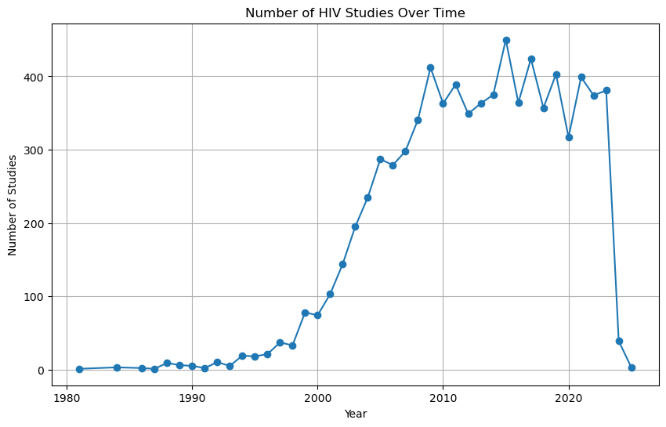

The distribution of HIV studies over the years shows an increase in the number of studies conducted over time. The number of studies is **relatively low in the early years (1980s and early 1990s) and starts to increase significantly from the mid-1990s onwards**. The peak in the number of studies is observed in the mid-2010s, and it remains relatively high in the following years. The year 2024 and 2025 have fewer studies, which might be due to the dataset's limitations or the availability of data.

This trend indicates a growing interest in HIV research and a continuous effort to understand and combat the HIV epidemic. The increasing number of studies reflects the importance of HIV research in public health and medical advancements.

- **Cancer Temporal Trends**

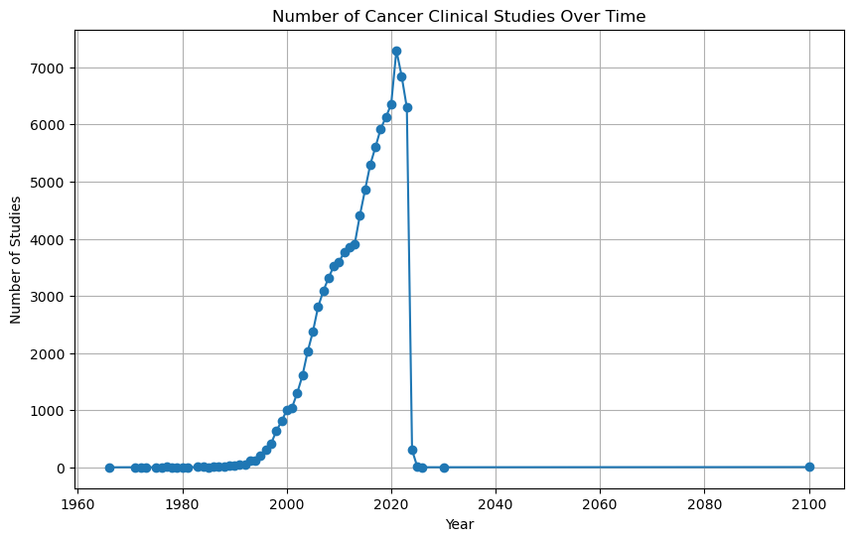

According to this plot, **the number of studies began increasing from 2000 to 2023**, as some are expected to begin from as 2024 and even 2100. Cancer studies are still on the rise.

**- Pneumonia Trends**

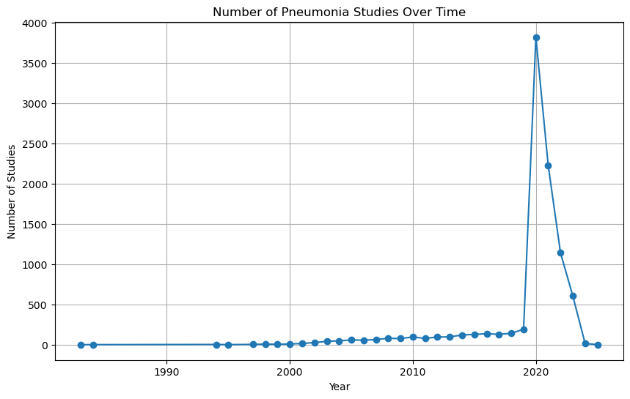

* The number of studies gradually increased over the years, with a **noticeable jump starting in 2020**.
* 2020 had a significant increase in the number of studies, indicating a potential focus on Pneumonia in response to global events (e.g., COVID-19 pandemic).
* The years **2020 and 2021 saw the highest number of Pneumonia studies, with 2020 having the most significant increase.**

#### OUTCOME MEASURES ANALYSIS

In this section, we delve into the primary and secondary outcome measures in the various clinical trials, highlighting the most frequently studied parameters and their clinical implications.

This involves examining the results and findings related to specific measures and metrics used in the study or research. We analyzed outcome measures to understand the impact and effectiveness of various interventions and treatments.

- **COVID-19 Outcome Measures**

1. Top Primary Outcomes

* Sustained recovery defined as being discharged from the index hospitalization, followed by being alive and home for 14 consecutive days prior to day 90.
* Adverse reactions/events rate, Occurrence of adverse reactions/events after vaccination, 28 days after vaccination.
* Adverse reactions/events rate, Occurrence of adverse reactions/events after vaccination, 7 days after vaccination.
* Time to clinical improvement, from date of randomization until 14 days later.
* Lung injury score, at 7 and 14 days.
* Time to sustained recovery in days. The reported summary is the median survival time, up to 28 days.
* Frequency of adverse events up to seven days after immunization following each immunization per age group, seven days after each immunization.

2.Top Secondary Outcomes

* Pulmonary ordinal outcome, oxygen requirements measured by 7 categories (1= least severe, 7=most severe). the participants highest i.e. most severe observed score is used, days 1-7, 14 and 28.
* No. of participants with hospitalization, urgent care, emergency room visit, or death, up to 28 days.
* No. of participants with Mortality, up to 28 days.
* Serious adverse event rate, report and analyze serious adverse events, 0 to 6 months.
* Pulmonary + ordinal outcome, extrapulmonary complications and respiratory dysfunction measured by 7 categories, days 1-7.
* Change in neutralizing antibody levels, baseline to days, 1, 3, 5, 28 and 90.
* Change in overall titers of antibodies, baseline to days 1,3,5,28 and 90.
* Days alive outside short-term acute care hospital, up to day 90.

- **Heart Disease Outcome Measures**

1. Top Primary Outcomes

* All-cause Mortality, one year
* Mortality
* Change of the arterial oxygen saturation during colored light exposure compared with baseline and a recovery period, 43 minutes.
* Change of the pulse-respiratory quotient during colored light exposure. The pulse-respiratory quotient will be calculated as heart rate divided by the respiration rate.
* Change of heart rate during colored light exposure compared with a baseline and a recovery period, 43 min (8 min baseline, 15 min colored, 20 min recovery).
* Change in cerebral tissue oxygen saturation during colored light exposure compared with a recovery period, 43 min.
* Safety.

2. Top 10 Secondary Outcomes

* Quality of life. (16 studies)
* Myocardial infarction (11 studies).
* Strone, 1 year (9 studies).
* Composite of cardiac death or MI, one month.
* Composite of death or MI, one month.
* Adverse events.
* Freedom from Coronary thrombosis, Freedom from Coronary thrombosis, During PCI.
* Freedom from No reflow, During PCI.
* Freedom from Coronary dissection > C, during PCI.
* Freedom from Coronary perforation, during PCI.

- **Malaria Outcome Measures**

1. Top 10 Primary Outcomes

* Malaria Incidence, Incidence of malaria infections among human cohorts during the follow-up period as detected by PCR, 104 weeks.
* Parasite clearance time.
* Fever clearance time.
* Sensitive or parasitological failure (RI, early and late, RII.
* Number of Patients with Adequate Clinical and Parasitological Response (ACPR).
* Parasitological failures will be classified as recrudescence or re-infection (or indeterminate) using GLURP and MSP I & II markers.
* parasite clearance
* Diagnostic specificity for malaria parasite detection, 6 months
* Parasite clearance

2. Top 10 Secondary Outcomes

* Fever clearance time.
* Parasite clearance time.
* Tumor marker level. The patient’s sensitive tumor markers will be reviewed periodically from the time they are enrolled into the study, 2 years.
* Association between study treatment and gametocyte carriage.
* 2 year of survival rate.
* Side effects.
* Tolerability by describing adverse events and changes in hematological parameters.
* Overall survival. The time starting from the treatment to death of whatever causes, 2 years.
* 1 year of survival rate.
* Time to clearance of fever.

**- HIV Outcome Measures**

1. Top Primary Outcomes

* Average no. of visits required to start ART, no. of health system interactions required between HIV diagnosis and first dispensing of ARVs, up to 6 months after treatment eligibility determined.
* Transcriptone analysis. Bulk RNA sequencing on extracted RNA, 5 years.
* Immunometabolic profile analysis, Mass spectrometry metabolomics will be used to study the immunometabolic profile of latently infected cells, 5 years.
* Immunohistochemistry, RNA and DNA in Situ Hybridization. Immunochemistry will be used to study the expression of activation and exhaustion markers on tissue samples, while viral expression will be assessed through DNAScope and RNAScope technologies, 5 years.
* Patient-months enrolled in any DSD model, % of all patient-months of ART provided for the cohort that are provided within DSD models, 12 months.
* Patient-months enrolled in any DSD model, % of all patient-months of ART provided for the cohort that are provided within DSD models, 24 months.
* Toxicity.
* Patient-months enrolled in ant DSD model, % of all patient-months of ART provided for the cohirt that are provided within DSD models, 6 months.
* High dimensional phenotyping, CyTOF ( mass cytometry Fluidigm) combined with bioinformatics approach to extensively characterize the phenotype of latently intected cells, 5 years.
* Proportion of patient survey participants with HIV viral suppression ≤400 copies/ml at most recent test, Viral suppression among ART patients enrolled and not enrolled in differentiated service delivery models, 12 months after enrollment.

2. Top Secondary Outcomes

* Change from Baseline in CD4+ Cell count at week 48.
* Safety.
* Change from Baseline in CD4+ Cell count at week 96.
* Change from Baseline in CD4+ Cell count at week 24.
* Viral load, 6 months.
* Percent change from baseline in Spine BMD at week 48, Spine BMD was assessed by DXA scan, baseline week 48.
* Percent change from baseline in Hip Bone Mineral Density (BMD) at week 48, Hip BMD was assessed by dual energy x-ray absorptiometry (DXA) scan, baseline week 48.
* Percent change from Baseline in Hip BMD at week 96, Hip BMD was assessed by DXA scan, baseline week 96.
* Percent change from baseline in spine BMD at week 96, spine BMD was assessed by DXA scan, baseline week 96.

**- Cancer Outcome Measures**

1. Top Primary Outcomes

* Overall survival.
* Toxicity.
* Safety.
* Progression-free survival
* Response rate.
* Disease free survival.
* Survival.
* Event-free survival.
* Overall survival, 2 years.
* Efficacy.

2. Top 10 Secondary Outcomes

* Overall survival.
* Toxicity.
* Progression-free survival.
* Quality of life.
* Overall survival, 5 years.
* Time to progression.
* Overall survival, 3 years.
* Overall survival, 1 year.
* Safety.
* Duration of response.

**- Pneumonia Outcome Measures**

1. Top 10 Primary Outcomes

* Time for randomization to sustained recovery. Sustained recovery defined as being discharged from the index hospitalization, followed by being alive and home for 14 consecutive days prior to day 90.
* Adverse reactions/events rate. occurrence of adverse reactions/events after vaccination, 28 days after vaccination.
* Adverse reactions/events rate, occurrence of adverse reactions/events after vaccination, 7 days after vaccination.
* Time to clinical improvement. Improvement of two points on a seven-category ordinal scale recommended by WHO or discharge from the hospital, whichever came first, from date of randomization until 14 days later.
* Lung injury score. Proportion of lung injury score decreased or increased after treatment, at 7 and 14 days.
* Baseline neutralizing antibody level. Neutralizing antibody geometric mean titer (GMT) against coronavirus before vaccination, day 0.
* Time to sustained recovery in days. Time to sustained recovery was the number of days between receipt of study drug and the third of 3 consecutive days without symptoms. Participants who died, by definition, did not recover regardless of reported symptom freedom. The reported summary is the median survival time, up to 28 days.
* No. of participants with adverse events. Determination of number of participants through the whole study, an average of 180 days.
* SARS-CoV-2 specific memory B and T cell response for the third dose immunization schedule, from 0 days to 6 months after the third dose.
* Total incidence of solicited reactions (systematic and local). Solicited reactions such as pain, tenderness, erythema/redness, induration/swelling, fever, nausea/vomiting, headache, fatigue/malaise, myalgia, arthralgia will be collected from the participants 7 days post-vaccination. Total incidence of solicited reactions will be measures for 7 days post booster vaccination.

2. Top 10 Secondary Outcomes

* Pulmonary ordinal outcome, oxygen requirements measured by 7 categories (1=least severe, 7=most severe). The participant’s highest i.e. most severe observed score is used, days 1-7, 14 and 28.
* Number of participants with mortality, up to 28 days.
* Mean days benefit as measured by the symptom and clinical event scale. The symptom and clinical event scale is a daily measurement that combines the global symptom burden scale with clinical events hospitalization and mortality. (No symptoms, mild symptoms, moderate symptoms, severe symptoms, hospitalized, deceased). The cumulative benefit of treatment A is the probability of experiencing a better outcome on treatment A compared to treatment B, summed over the days of follow-up. The difference between the cumulative benefit of treatment A and the cumulative benefit of treatment B is known as the difference in days benefit. Measure of dispersion is 95% credible interval., Up to 14 days .
* Number of participants with hospitalization, urgent care, emergency room visit, or death, up to 28 days.
* Change in SARS-CoV-2 neutralizing antibody levels, baseline to days 1, 3, 5, 28, and 90.
* Pulmonary + ordinal outcome, extrapulmonary complications and respiratory dysfunction measured by 7 categories (1=least severe, 7=most severe). The participants’ highest (i.e. most severe) observed score is used, days 1-7.
* Time unwell in days as measured by the symptom and clinical event scale. it is a daily measurement that combines the global symptom burden scale with clinical events hospitalization and mortality. ( No symptoms, mild symptoms, moderate symptoms, severe symptoms, hospitalized, deceased). Time unwell was the portion of follow-up (in days) that a participant was symptomatic, hospitalized, or deceased. The quantity is estimated from a Bayesian longitudinal ordinal regression model with covariate adjustment and weekly informative priors, up to 14 days.
* Days alive outside short-term acute care hospital, up to day 90.
* Change in overall titers of antibodies, baseline to days 1, 3, 5, 28 and 90.

#### PUBLICATION TRENDS:

This section examines the publication trends in each disease category, providing insights into the volume and frequency of research papers and clinical trial publications over time.

* **Publication of Covid-19 studies trends**

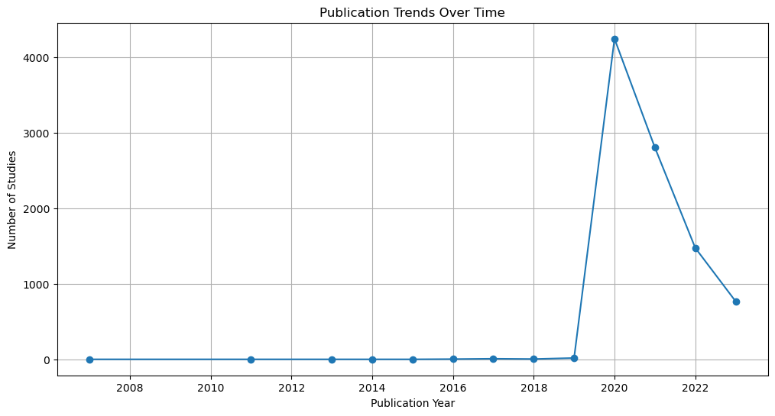

**Before the Pandemic (2007-2017)**: There were occasional publications on COVID-19 before the pandemic began. The number of studies published during these years remained relatively low, with an average of less than 10 studies per year. This suggests that COVID-19 was not a major focus of research during this period.

**Pandemic Onset and Surge (2018-2020)**: In 2019, as the COVID-19 pandemic emerged, the number of publications started to increase significantly. In 2020, there was a substantial surge in research and publications, with 4,248 studies published. This sharp increase is a clear reflection of the global impact of the pandemic, prompting researchers to study the virus, its transmission, treatment, and prevention.

**Pandemic Response (2021-2023**): The high publication volume continued in 2021, with 2,807 studies. In 2022 and 2023, there were still substantial numbers of publications (1,477 and 769, respectively). This sustained research activity indicates that COVID-19 remained a significant public health concern, and researchers continued to investigate the virus, its variants, and long-term effects.

The data shows a strong correlation between the emergence of the COVID-19 pandemic and the surge in research efforts. The global scientific community responded rapidly to the pandemic by conducting extensive research, leading to a wealth of knowledge about the virus, its variants, and potential interventions. These findings have been crucial for the development of vaccines, treatment strategies, and public health measures.

* **Publication of Cancer studies trends**

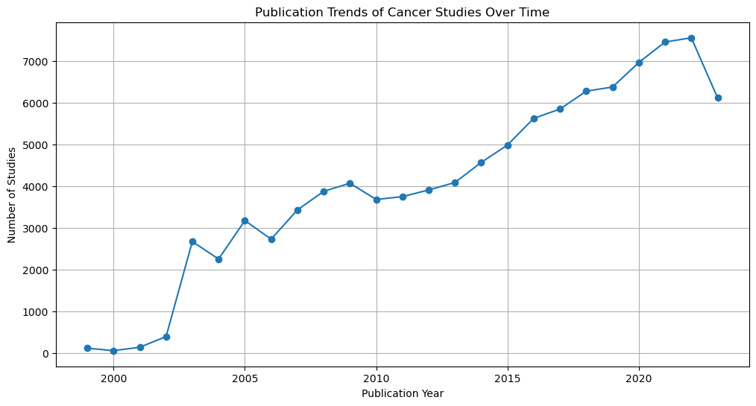

Cancer is a complex and challenging disease that continues to be a major focus of scientific and medical research. The study of cancer is critical for improving our understanding of its causes, prevention, diagnosis, and treatment. The publication trends related to cancer research provide insights into the dynamic nature of this field and its growing significance.

**Publication Trends:**

1. **Early Years:** In the late 1990s, cancer research had a notable presence in the scientific community, with 123 publications in 1999. The number of publications increased steadily in the following years.
2. **Significant Growth:** The period between 2002 and 2008 witnessed a substantial surge in publications. The number of publications in 2008 reached 3,881, reflecting the increasing research efforts to combat cancer.
3. **Continued Expansion:** The following years maintained this growth, with a consistent increase in the number of publications. Notably, 2020 saw a peak of 6,970 publications, reflecting the heightened research activity in the face of global health challenges.
4. **Sustained Research:** From 2014 onwards, the number of publications has consistently exceeded 4,000 annually, indicating a sustained commitment to understanding and addressing the complexities of cancer.
5. **2022 and Beyond:** In 2022, there were 7,562 publications, suggesting that cancer research remains a vibrant field with ongoing contributions from the scientific community.

**Significance:** The upward trajectory of cancer research publications underscores the urgency of finding innovative solutions to address this formidable health issue. Researchers, healthcare professionals, and organizations worldwide are dedicated to advancing our knowledge of cancer's underlying mechanisms and improving treatments for patients.

* **Publication of HIV studies trends**

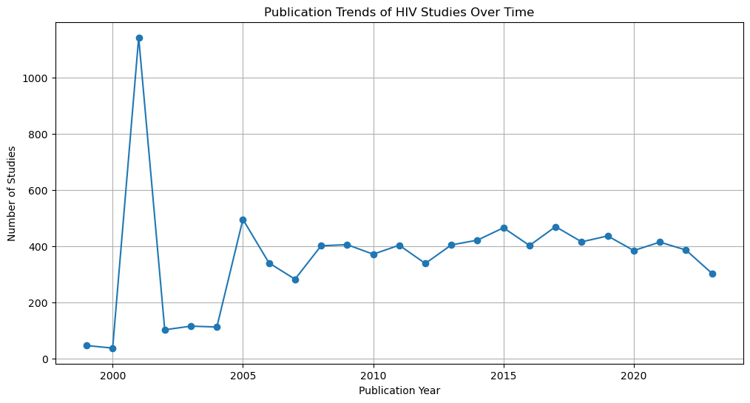

The data represents the publication trends for studies related to pneumonia over the years.

* **From 1999 to 2003, the number of publications was relatively low, ranging from 3 to 82 publications per year.**
* A noticeable increase in publications is seen from **2004 onwards, with the number of publications exceeding 100 each year.**
* The trend continues to rise steadily from 2004 to 2019, indicating sustained research activities in the field of pneumonia.
* In **2020, there is a significant surge in publications, with 3,508 new publications.** This exceptional increase may be attributed to the COVID-19 pandemic, which likely influenced research priorities and increased the overall volume of publications.
* In 2021, while the number of publications remained high, there was a notable decrease compared to 2020, with 2,387 publications.
* In 2022, the number of publications further decreased, with 1,313 publications.
* In 2023, the trend continues, with 741 publications. This decrease may be due to various factors, including the maturation of existing research and shifts in research focus.

In summary, the data demonstrates the dynamic nature of research in the field of pneumonia, with a significant surge in publications during the COVID-19 pandemic, followed by a tapering trend as research priorities evolve and mature. It's important to note that external factors, emerging diseases, and healthcare priorities can significantly impact publication trends in the medical field.

* **Publication of Pneumonia studies trends**

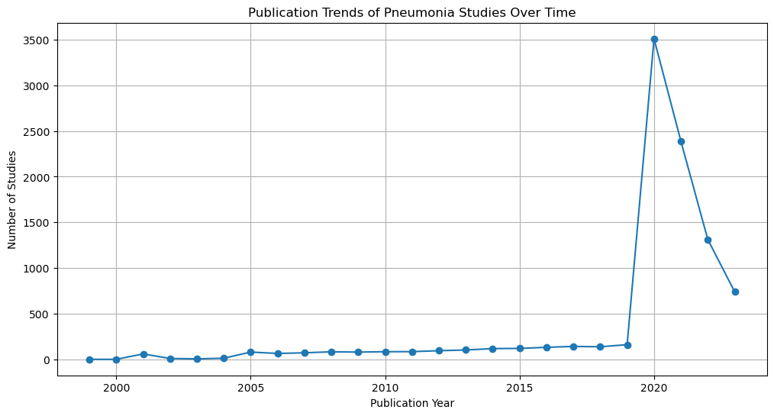

The data represents the publication trends for studies related to pneumonia over the years:

From 1999 to 2003, the number of publications was relatively low, ranging from 3 to 82 publications per year.

A noticeable increase in publications is seen from 2004 onwards, with the number of publications exceeding 100 each year.

The trend continues to rise steadily from 2004 to 2019, indicating sustained research activities in the field of pneumonia.

In 2020, there is a significant surge in publications, with 3,508 new publications. This exceptional increase may be attributed to the COVID-19 pandemic, which likely influenced research priorities and increased the overall volume of publications.

In 2021, while the number of publications remained high, there was a notable decrease compared to 2020, with 2,387 publications.

In 2022, the number of publications further decreased, with 1,313 publications.

In 2023, the trend continues, with 741 publications. This decrease may be due to various factors, including the maturation of existing research and shifts in research focus.

In summary, the data demonstrates the dynamic nature of research in the field of pneumonia, with a significant surge in publications during the COVID-19 pandemic, followed by a tapering trend as research priorities evolve and mature. It's important to note that external factors, emerging diseases, and healthcare priorities can significantly impact publication trends in the medical field.

* **Publication of Malaria studies trends**

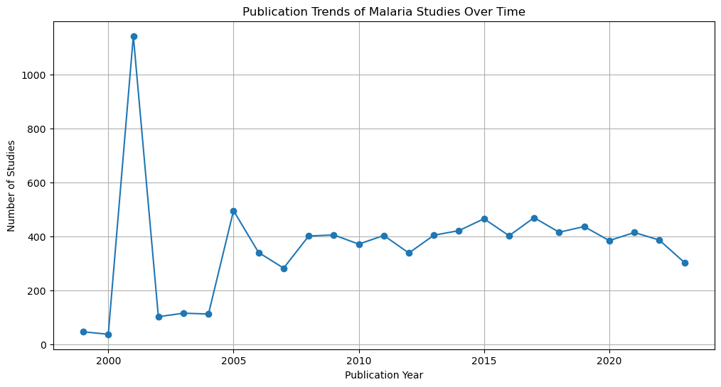

The data represents the publication trends for studies related to malaria over the years. Here's the interpretation:

* In 1999, there were 47 publications related to malaria studies.
* In 2000, the number of publications decreased to 38, indicating a drop in research interest during that year.
* The trend in 2001 shows a significant increase in the number of publications to 1,143. This substantial increase suggests a renewed focus on malaria research.
* In 2002, there is a decrease in publications to 103, possibly due to variations in research priorities.
* In 2003, the number of publications increased slightly to 116.
* In 2004, there were 113 publications, indicating consistent interest in malaria research.
* From 2005 onwards, there is a noticeable upward trend in the number of publications.
* In 2005, there was a significant increase to 496 publications, indicating a growing interest in understanding and combating malaria.
* The number of publications continues to increase in the following years.
* In 2014, there were 422 publications, suggesting ongoing research and interest in malaria.
* In 2015, there was a notable increase to 466 publications, possibly indicating increased efforts to combat malaria and its impact on global health.
* The number of publications remained relatively high in the subsequent years, indicating sustained research activity in this field.
* In 2020, there were 385 publications, suggesting that despite the challenges posed by the COVID-19 pandemic, malaria research remained a priority.
* In 2021, the trend continues, with 415 publications.
* In 2022, there were 387 publications, indicating sustained interest in malaria research.
* In 2023, there was a slight decrease in the number of publications to 304, but the research interest remains.

The data shows that malaria research has been a consistent area of focus over the years, with fluctuations possibly influenced by various factors, including funding, public health priorities, and global events. Researchers and organizations continue to invest in understanding, preventing, and treating malaria, reflecting the importance of this infectious disease in global health efforts.

* **Publication of Heart studies trends**

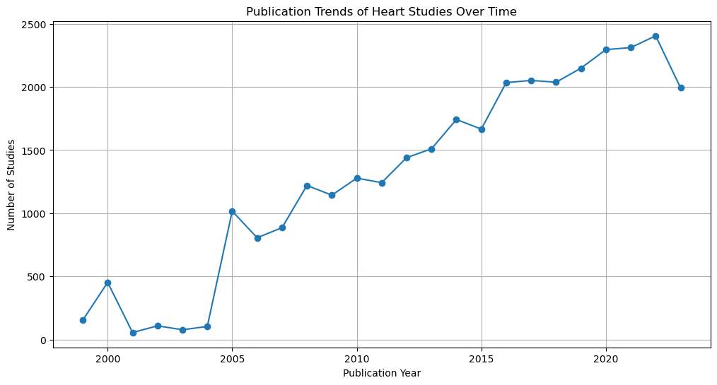

The data represents the publication trends for studies related to heart disease over the years.

* In 1999, there were 154 publications related to heart disease studies.
* In 2000, the number of publications increased significantly to 453, indicating a growing interest in heart disease research.
* In 2001, there was a noticeable drop in the number of publications, with only 56 publications.
* The trend in 2002 shows a slight increase to 109 publications.
* In 2003, the number of publications decreased to 78.
* From 2004 onwards, there is a consistent upward trend in the number of publications, with some fluctuations.
* Notably, there is a significant increase in 2005, with 1,017 publications. This could be attributed to increased research and awareness of heart disease, treatment options, and prevention strategies.
* The number of publications continues to increase steadily in the following years.
* In 2020 and 2021, there was a substantial increase in publications, with 2,295 and 2,311 publications, respectively. The ongoing COVID-19 pandemic may have influenced the focus on heart disease research, as it is a significant comorbidity with COVID-19.
* In 2022, the trend continues, with 2,404 publications.
* In 2023, there is a slight decrease in the number of publications to 1,992.

The data indicates that heart disease research has been a growing area of interest, with a substantial increase in publications in recent years. This could be attributed to advancements in cardiovascular medicine, increased awareness of heart health, and the growing global burden of heart-related conditions. Researchers and healthcare professionals are actively working to understand, treat, and prevent heart diseases, making it a key area of medical research and public health concern.

#### DRUG AND INTERVENTION ANALYSIS

**- COVID-19 Drug and Intervention Analysis**

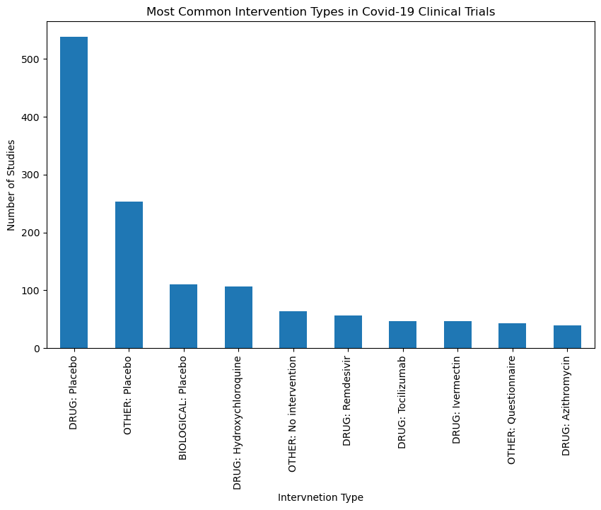

## Analysis

* DRUG Interventions: The most common interventions in COVID-19 clinical trials are related to drugs, with "**DRUG: Placebo**" having the highest count. This indicates a significant focus on testing pharmaceutical treatments.
* **Placebo Comparisons**: Placebo-controlled trials, including "DRUG: Placebo" and "OTHER: Placebo," are common. These trials typically involve comparing the effects of a drug against a placebo to assess its efficacy.
* **BIOLOGICAL Interventions**: "BIOLOGICAL: Placebo" suggests the use of biological therapies, often in comparison to placebos.
* **Specific Drugs**: Trials involving drugs like "Hydroxychloroquine," "Remdesivir," "Tocilizumab," and "Ivermectin" indicate an interest in assessing the efficacy of these specific treatments.
* **No Intervention: "OTHER: No intervention**" trials are less common but might focus on the natural progression of the disease without any specific treatment.
* Questionnaires: "OTHER: Questionnaire" trials may involve data collection and surveys rather than physical interventions.

### Interpretation

The analysis of intervention types reveals the diverse approaches taken in COVID-19 clinical trials. Researchers are exploring various treatment options, including pharmaceuticals and biological therapies, often comparing them to placebos. The presence of questionnaires indicates studies that collect data through surveys and questionnaires rather than medical interventions. This diversity in interventions reflects the complexity of COVID-19 research and the quest for effective treatments.

- **Heart Disease Drug and Intervention Analysis**

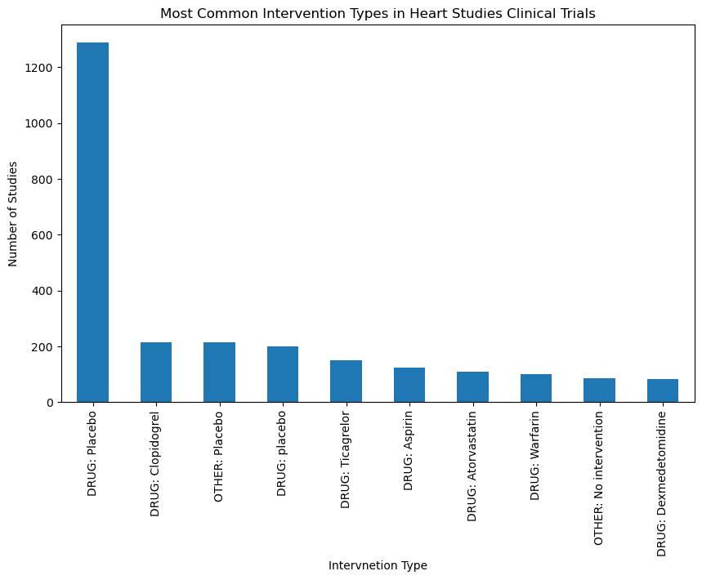

- **Malaria Drug and Intervention Analysis**

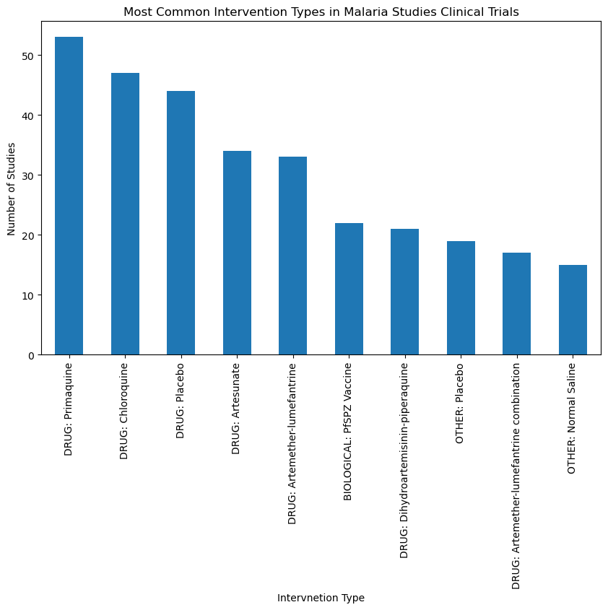 **DRUG: Primaquine (53 occurrences)**: Primaquine is an antimalarial drug used for the treatment of Plasmodium vivax malaria and prevention of relapses. Its frequent appearance indicates its significance in malaria studies.

**DRUG: Chloroquine (47 occurrences)**: Chloroquine was historically used as an antimalarial drug, and its continued presence suggests its relevance in research, despite reduced effectiveness due to drug resistance.

**DRUG: Placebo (44 occurrences)**: Placebo is often used in clinical trials as a control group to compare the effects of other interventions. Its inclusion demonstrates the importance of rigorous testing in malaria research.

**DRUG: Artesunate (34 occurrences)**: Artesunate is an artemisinin-based antimalarial drug known for its efficacy in treating severe malaria. Its use is pivotal in studies aiming to improve malaria treatment.

**DRUG: Artemether-lumefantrine (33 occurrences)**: This combination drug is a first-line treatment for uncomplicated malaria. Its presence underscores its role in malaria research and treatment.

**BIOLOGICAL: PfSPZ Vaccine (22 occurrences)**: PfSPZ vaccine represents a type of malaria vaccine. Its inclusion points to the exploration of novel approaches, including vaccines, in malaria prevention.

**DRUG: Dihydroartemisinin-piperaquine (21 occurrences)**: This is another artemisinin-based combination therapy used in malaria treatment. Its frequent appearance suggests its evaluation and efficacy in malaria control.

**OTHER: Placebo (19 occurrences)**: Similar to "DRUG: Placebo," this category includes placebo interventions used as control groups in studies. It reflects the importance of placebo-controlled trials in malaria research.

**DRUG: Artemether-lumefantrine combination (17 occurrences)**: This combination drug is a crucial component of malaria treatment, especially in regions where malaria is prevalent.

**OTHER: Normal Saline (15 occurrences)**: Normal saline may be used as a control or placebo intervention in some studies. Its presence emphasizes the importance of control groups in research.

### Interpretation:

The variety of intervention types in malaria studies reflects the diverse approaches taken to understand, treat, and prevent malaria. These interventions include antimalarial drugs, vaccines, placebos, and other treatments, showcasing the ongoing efforts to combat malaria using different strategies and interventions.

- **HIV Drug and Intervention Analysis**

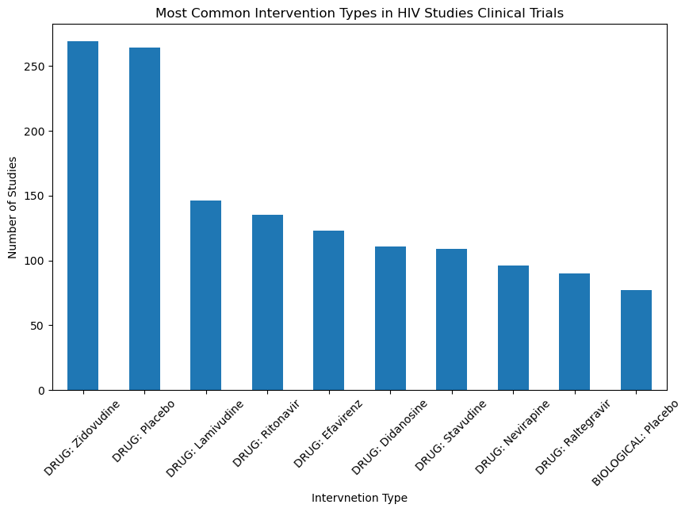

**DRUG: Zidovudine**: Zidovudine is the **most common intervention** in the dataset, with 269 studies using this drug. It is a well-known antiretroviral medication used in HIV treatment.

**DRUG: Placebo**: Placebo interventions were used in 264 studies. Placebos are often used in clinical trials as a control to compare the effects of other interventions.

**DRUG: Lamivudine**: Lamivudine is another antiretroviral drug used in 146 studies. It is commonly included in HIV treatment regimens.

**DRUG: Ritonavir**: Ritonavir was used in 135 studies. It is a protease inhibitor commonly used in HIV therapy.

**DRUG: Efavirenz**: Efavirenz is an antiretroviral medication used in 123 studies. It is often included in combination therapy for HIV.

**DRUG: Didanosine**: Didanosine was used in 111 studies. It is another antiretroviral drug used to manage HIV.

**DRUG: Stavudine**: Stavudine is included in 109 studies and is known for its use in HIV treatment.

**DRUG: Nevirapine**: Nevirapine is an intervention in 96 studies. It is often used in preventing mother-to-child transmission of HIV.

**DRUG: Raltegravir**: Raltegravir is included in 90 studies. It's an integrase inhibitor used in HIV treatment.

**BIOLOGICAL: Placebo**: Placebo interventions, likely in the form of biological placebos, were used in 77 studies. These placebos are used to compare the effects of biological interventions.

These interventions mainly consist of antiretroviral drugs, which are essential for managing and treating HIV. Additionally, placebos are used to establish control groups in clinical trials, allowing researchers to evaluate the effectiveness of new interventions.

- **Cancer Drug and Intervention Analysis**

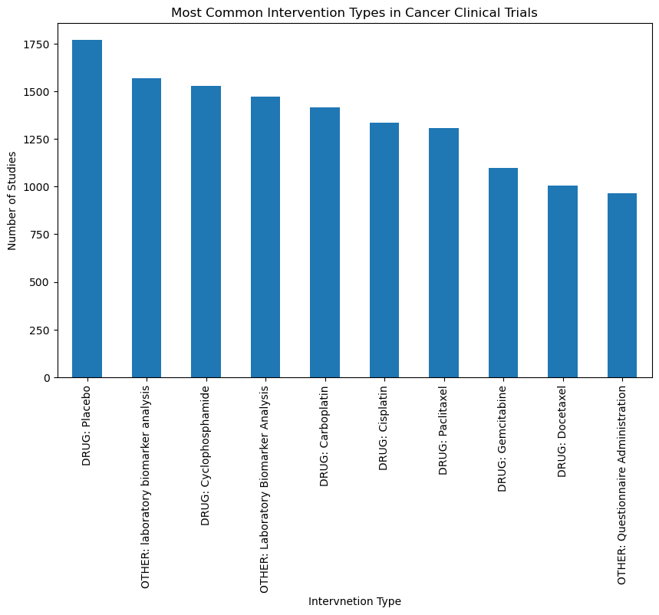

- **Pneumonia Drug and Intervention Analysis**

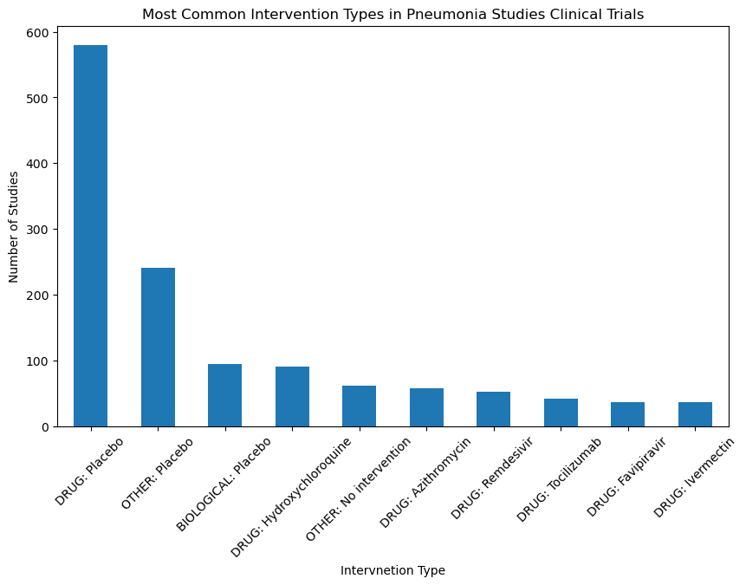

**DRUG: Placebo (580 studies)**: Placebo-controlled studies involve using an inactive substance (placebo) to assess the effectiveness of new drugs or treatments for pneumonia. These studies help determine whether the new intervention offers significant benefits over a placebo.

**OTHER: Placebo (241 studies)**: This likely represents studies where a non-standard or specific type of placebo is being used in clinical trials for pneumonia research. These placebos may have variations from the standard placebo.

**BIOLOGICAL: Placebo (95 studies)**: Biological placebos are placebos made from biologically inactive substances, such as saline, to mimic the administration of a biological treatment. The use of biological placebos can help assess the effectiveness of biologic interventions.

**DRUG: Hydroxychloroquine (90 studies)**: Hydroxychloroquine has been studied in the context of pneumonia treatment, especially during the COVID-19 pandemic. These studies investigate its potential effectiveness in managing pneumonia symptoms.

**OTHER: No intervention (61 studies)**: In these studies, patients with pneumonia may receive no specific treatment or intervention. Researchers might be interested in understanding the natural course of the disease in the absence of medical intervention.

**DRUG: Azithromycin (58 studies)**: Azithromycin is an antibiotic that has been investigated for its potential role in treating pneumonia, especially when the cause is bacterial. Studies involving azithromycin aim to assess its effectiveness.

**DRUG: Remdesivir (53 studies)**: Remdesivir was initially studied for its antiviral properties in pneumonia, particularly for viral pneumonia cases. These studies examine its potential to reduce the severity and duration of the illness.

**DRUG: Tocilizumab (42 studies)**: Tocilizumab is an immunosuppressive drug used to manage severe inflammation. Studies involving tocilizumab aim to determine its efficacy in mitigating the inflammatory response often associated with pneumonia.

**DRUG: Favipiravir (37 studies)**: Favipiravir is an antiviral medication that has been studied in the context of viral pneumonia, including pneumonia caused by emerging infectious diseases. These studies assess its antiviral properties.

**DRUG: Ivermectin (36 studies)**: Ivermectin has been investigated for its potential antiviral and anti-inflammatory properties in the context of pneumonia, particularly during the COVID-19 pandemic.

#### COLLABORATION NETWORKS

Each subsection focuses on the top collaborating institutions, shedding light on key players in each field and the strength of collaborative networks.

- **COVID-19 Collaboration Networks**

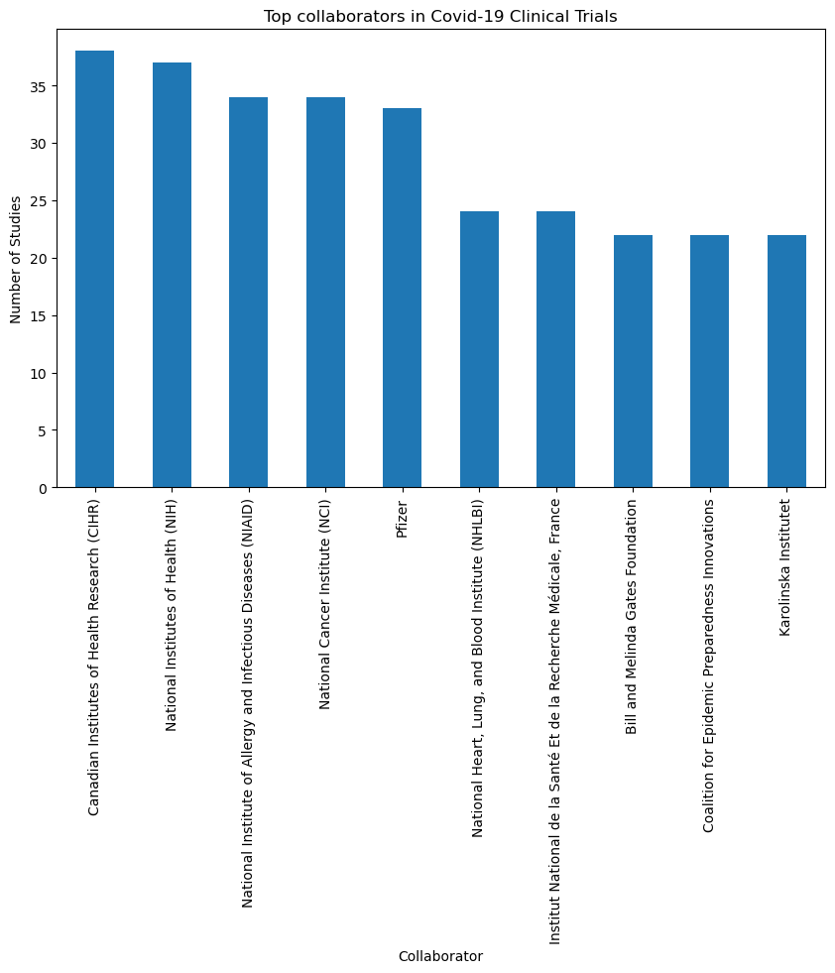

### Analysis:

* **Canadian Institutes of Health Research (CIHR) and National Institutes of Health (NIH**): These two organizations are the leading collaborators in COVID-19 studies, with 38 and 37 collaborations, respectively.
* **National Institute of Allergy and Infectious Diseases (NIAID) and National Cancer Institute (NCI):** These institutes have contributed significantly to collaborative research, each having 34 collaborations.
* **Pfizer**: The pharmaceutical company Pfizer is also a major collaborator with 33 collaborations.
* **National Heart, Lung, and Blood Institute (NHLBI), Institut National de la Santé Et de la Recherche Médicale (France), Bill and Melinda Gates Foundation, Coalition for Epidemic Preparedness Innovations, and Karolinska Institutet**: These organizations have collaborated actively with 22 collaborations each.

### Interpretation:

The analysis of top collaborators in COVID-19 studies reveals organizations and institutes that have played a prominent role in collaborative research efforts. These collaborations may involve joint research projects, funding support, or data sharing, indicating the importance of international and cross-disciplinary collaboration in addressing the COVID-19 pandemic. Understanding the top collaborators can help identify key research partners and collaborative networks in the field.

- **Heart Disease Collaboration Networks**

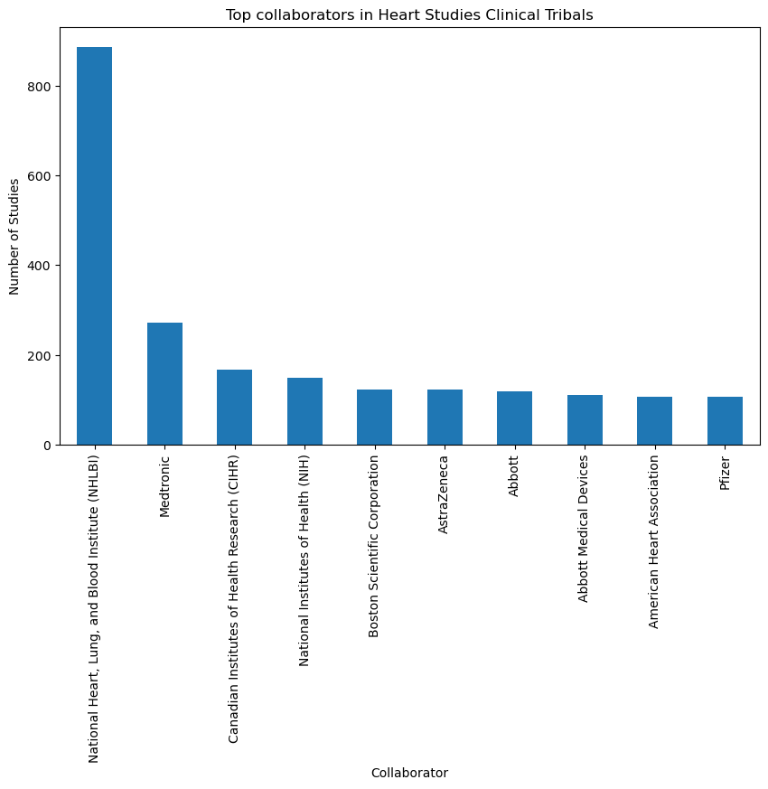

- **Malaria Collaboration Networks**

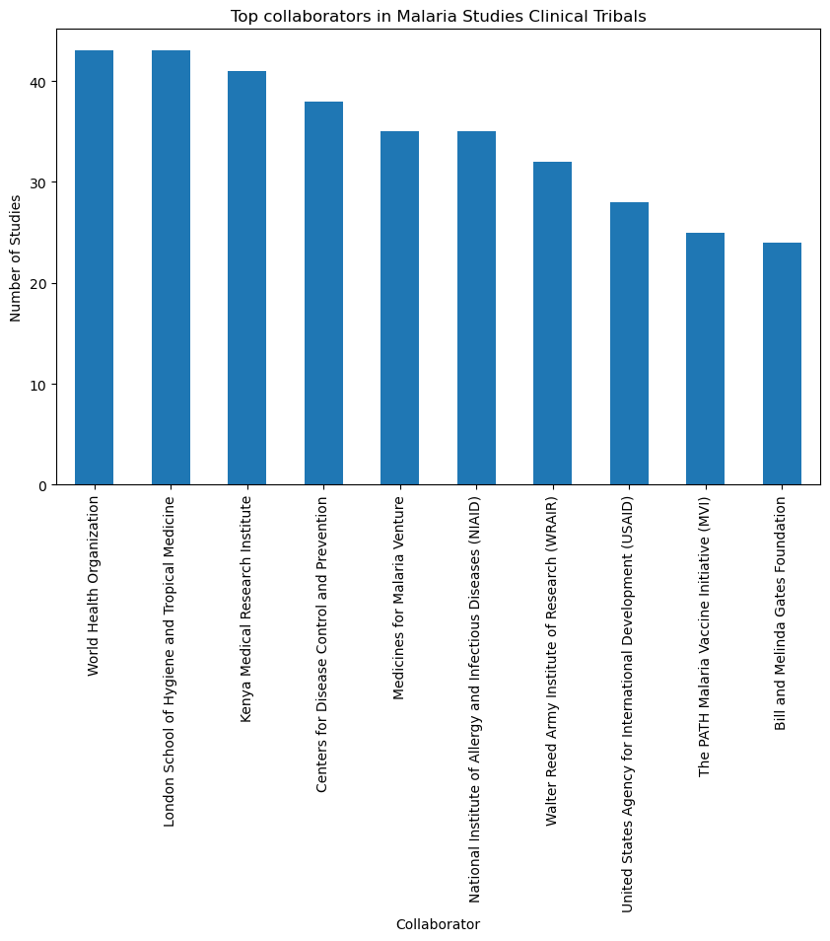

**World Health Organization (WHO)**: WHO is a **prominent international organization involved in global health efforts**. Its sponsorship of malaria studies indicates a commitment to understanding and combating malaria's impact worldwide.

**London School of Hygiene and Tropical Medicine**: This renowned institution is dedicated to research and education in the fields of hygiene, epidemiology, and tropical medicine. Its involvement suggests a focus on malaria research, particularly in tropical regions.

**Kenya Medical Research Institute**: A key research institution in Kenya, its sponsorship emphasizes the significance of studying malaria in regions with a high malaria burden, like Kenya.

**Centres for Disease Control and Prevention (CDC)**: CDC is a U.S. government agency focused on public health. Its involvement indicates a commitment to global efforts to control and prevent malaria.

**Medicines for Malaria Venture**: This organization is dedicated to developing and facilitating the delivery of new antimalarial drugs. Its sponsorship highlights the importance of drug research in malaria control.

**National Institute of Allergy and Infectious Diseases (NIAID)**: NIAID is part of the U.S. National Institutes of Health (NIH) and plays a crucial role in funding and conducting research on infectious diseases, including malaria.

**Walter Reed Army Institute of Research (WRAIR)**: This U.S. military research institute is actively engaged in various health-related research efforts, including malaria studies.

**United States Agency for International Development (USAID)**: USAID's involvement signifies the U.S. government's commitment to supporting global health initiatives, including malaria research and control.

**The PATH Malaria Vaccine Initiative (MVI)**: PATH MVI is dedicated to accelerating the development of malaria vaccines, indicating a focus on vaccine-related research.

**Bill and Melinda Gates Foundation**: The Gates Foundation has been a major player in global health, including efforts to combat malaria. Its sponsorship underlines the importance of philanthropic organizations in malaria research and intervention.

### Interpretation:

The presence of a diverse group of sponsors, including international organizations, research institutions, and philanthropic foundations, demonstrates the collaborative and multi-sectoral approach to malaria research. These organizations play pivotal roles in funding, conducting, and supporting studies aimed at better understanding, preventing, and treating malaria, which remains a global health priority.

- **HIV Collaboration Networks**

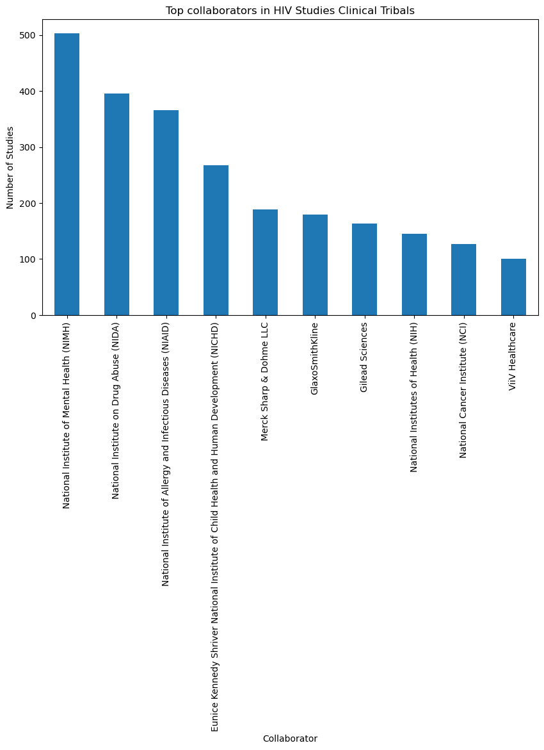

**National Institute of Mental Health (NIMH)**: This organization has collaborated in *503 HIV studies*. NIMH's involvement suggests a focus on the mental health aspects of HIV.

**National Institute on Drug Abuse (NIDA)**: NIDA has participated in *396 studies*, indicating a significant interest in understanding the relationship between drug abuse and HIV.

**National Institute of Allergy and Infectious Diseases (NIAID)**: NIAID has been a collaborator in *366 studies*, emphasizing the importance of infectious disease research in the context of HIV.

**Eunice Kennedy Shriver National Institute of Child Health and Human Development (NICHD)**: NICHD has contributed to *268 studies*, suggesting a focus on pediatric and maternal health aspects of HIV.

**Merck Sharp & Dohme LLC**: This pharmaceutical company has participated in *189 studies*, likely involved in the development of HIV-related medications.

**GlaxoSmithKline**: With *179 studies*, GlaxoSmithKline has played a role in the research and development of HIV treatments and prevention methods.

**Gilead Sciences**: Gilead Sciences has collaborated in *164 studies*, indicating a focus on antiretroviral therapies and HIV treatment.

**National Institutes of Health (NIH)**: NIH, a major player in healthcare research, has been involved in *145 studies*, covering a wide range of HIV-related research areas.

**National Cancer Institute (NCI)**: NCI has participated in *127 studies*, likely focusing on HIV-associated cancers.

**ViiV Healthcare**: This pharmaceutical company has collaborated in *101 studies*, likely involved in the development of HIV treatments and therapeutics.

These collaborators represent a diverse set of organizations and institutions actively contributing to the advancement of HIV research, from various medical and research angles. Their involvement is critical for comprehensive and multidisciplinary HIV studies.

- **Pneumonia Collaboration Networks**

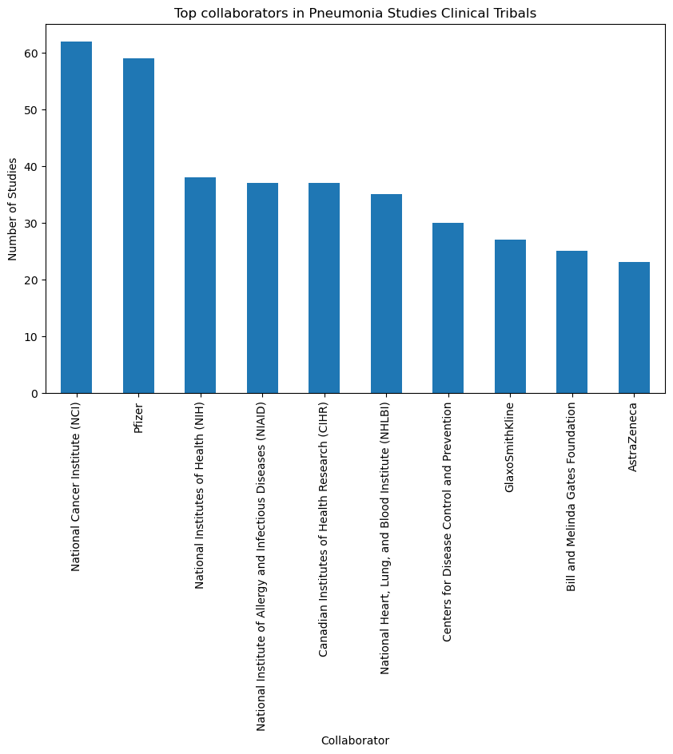

**National Cancer Institute (NCI)**: NCI's involvement in 62 studies suggests their interest in exploring the connections between pneumonia and cancer, as well as studying pneumonia-related complications and treatments in cancer patients.

**Pfizer**: Pfizer is actively participating in 59 studies, indicating a strong commitment to developing pharmaceutical solutions for pneumonia management and prevention.

**National Institutes of Health (NIH)**: NIH's participation in 38 studies underscores their dedication to funding and conducting research on pneumonia, likely with a focus on public health and biomedical research.

**National Institute of Allergy and Infectious Diseases (NIAID)**: NIAID's involvement in 37 studies suggests a focus on infectious aspects of pneumonia, such as viral or bacterial causes and vaccine development.

**Canadian Institutes of Health Research (CIHR)**: CIHR's collaboration in 37 studies highlights their role in supporting research on pneumonia, particularly in a Canadian context.

* **Cancer Collaboration Networks**

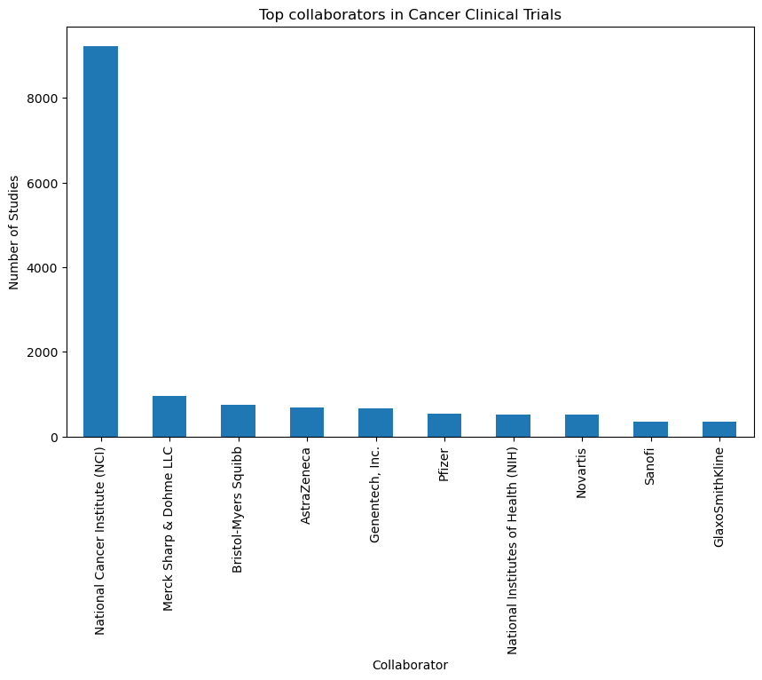

#### SPONSORSHIP ANALYSIS

This section provides insights into the entities funding the clinical trials, emphasizing the diversity and prominence of sponsors in each disease category.

- **COVID-19 Sponsorship Analysis**

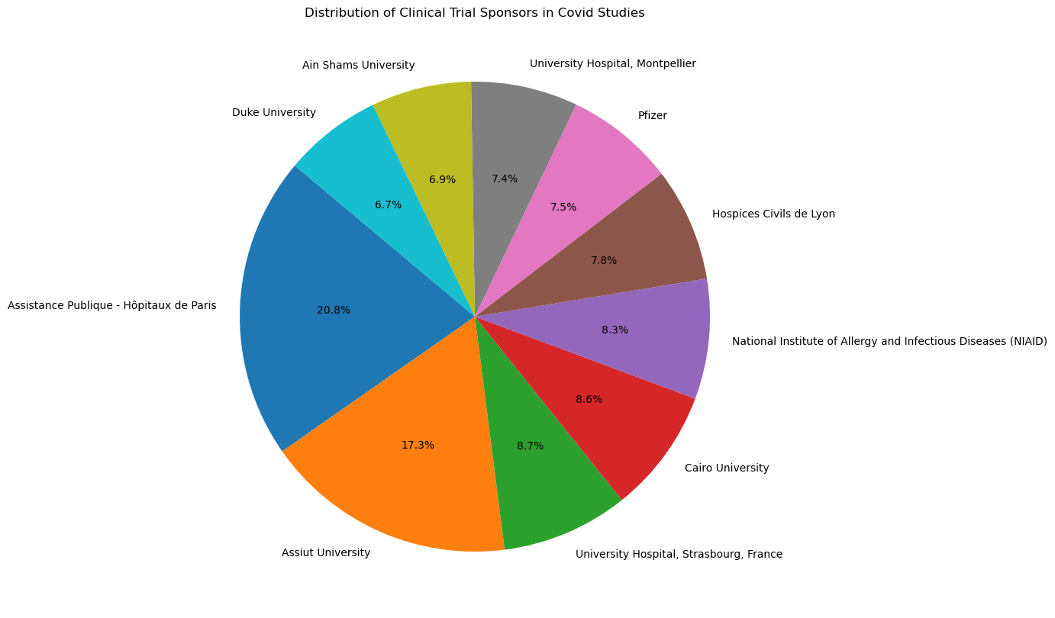

1**. Assistance Publique - Hôpitaux de Paris (AP-HP):** With 136 studies, Assistance Publique - Hôpitaux de Paris is a major sponsor of COVID-19 studies. AP-HP is the public hospital system in Paris, France, and has been actively involved in various COVID-19 research initiatives.

2**. Assiut University**:Assiut University, with 113 studies, is a prominent institution sponsoring COVID-19 research. It's located in Assiut, Egypt, and has been contributing to the global efforts in understanding and combatting the COVID-19 pandemic.

3**. University Hospital, Strasbourg, France**: This hospital, located in Strasbourg, France, has sponsored 57 COVID-19 studies. Hospital-based research centres often play a crucial role in conducting clinical studies related to infectious diseases.

4. **Cairo University**: Cairo University, with 56 studies, is another significant contributor to COVID-19 research. As one of Egypt's leading universities, it has been actively engaged in COVID-19 studies.

5. **National Institute of Allergy and Infectious Diseases (NIAID)**: NIAID, a division of the U.S. National Institutes of Health (NIH), is involved in 54 COVID-19 studies. NIAID plays a vital role in infectious disease research and has been at the forefront of the global response to the pandemic.

These sponsors have played a critical role in advancing our understanding of COVID-19 and developing strategies to manage and prevent its spread. Their support is essential for conducting the clinical trials and studies necessary to combat this global health crisis.

- **Heart Disease Sponsorship Analysis**

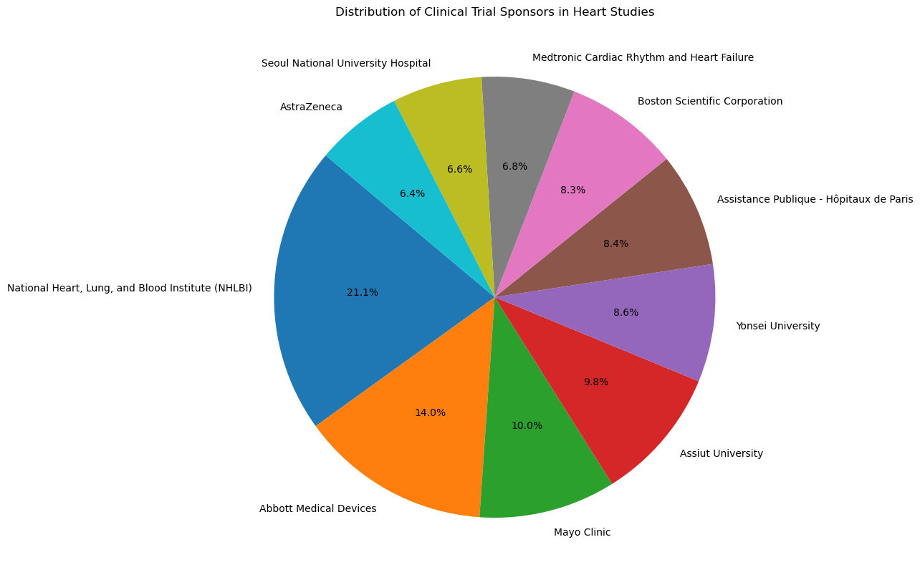

1**. National Heart, Lung, and Blood Institute (NHLBI**): NHLBI is a key sponsor in heart disease research, focusing on improving public health by conducting and supporting research related to the prevention, diagnosis, and treatment of heart, lung, and blood diseases.

2. **Abbott Medical Devices**: Abbott is a medical device company known for its contributions to cardiovascular care and heart disease management. Their sponsorship signifies their commitment to advancing medical technology in this field.

3**. Mayo Clinic**: A renowned medical institution, Mayo Clinic conducts cutting-edge research and provides high-quality patient care for heart diseases, making it an important contributor to heart disease studies.

4**. Assiut University**: Assiut University's involvement in sponsorship highlights their dedication to research and education, focusing on cardiovascular health and heart disease.

5. **Yonsei University**: Yonsei University plays a role in heart disease research, contributing to our understanding of cardiovascular health and the development of treatment methods.

6. **Assistance Publique - Hôpitaux de Paris**: This healthcare system in Paris, France, sponsors research to improve heart disease management and patient outcomes.

7. **Boston Scientific Corporation**: Boston Scientific is a global medical technology company, known for its innovations in cardiac care and its role in supporting research and development in this field.

8**. Medtronic Cardiac Rhythm and Heart Failure**: Medtronic specializes in medical devices related to cardiac care, including the treatment of heart rhythm disorders and heart failure.

9**. Seoul National University Hospital**: This academic hospital conducts research and provides medical care, contributing to the advancement of knowledge in the field of heart diseases.

10. **AstraZeneca:** AstraZeneca, a multinational pharmaceutical company, is actively involved in cardiovascular research, aiming to develop new therapies and medications for heart diseases.

These sponsors collectively support and advance heart disease research, which is essential in addressing the challenges and improving outcomes for individuals with heart-related conditions. Their contributions are critical to finding better ways to prevent, diagnose, and treat heart diseases.

- **Malaria Sponsorship Analysis**

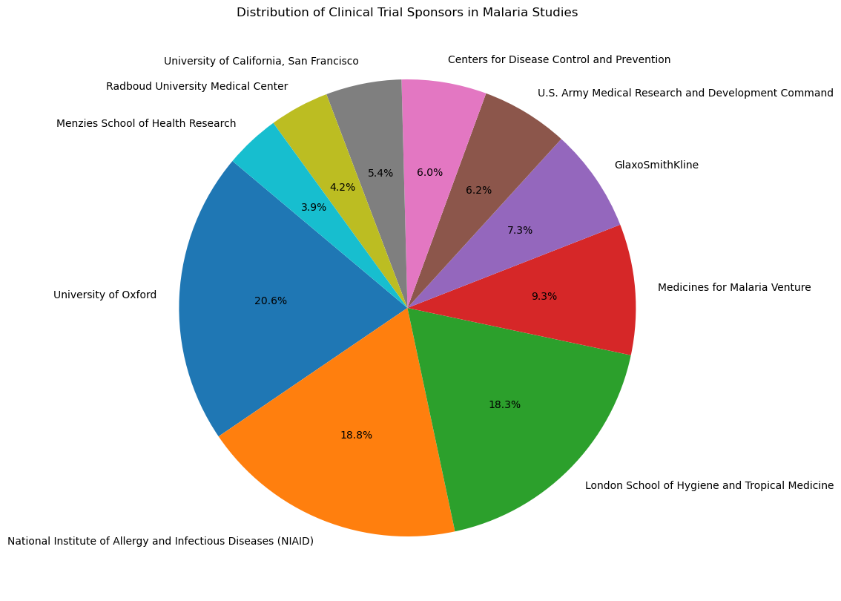

**University of Oxford (127 occurrences)**: The University of Oxford is a prestigious academic institution known for its contributions to various fields, including medical research. Its significant involvement as a sponsor in malaria studies indicates its dedication to advancing knowledge and interventions in the field.

**National Institute of Allergy and Infectious Diseases (NIAID) (116 occurrences)**: NIAID is a part of the U.S. National Institutes of Health (NIH) and plays a critical role in funding and conducting research on infectious diseases, including malaria. Its involvement emphasizes the U.S. government's commitment to global health efforts.

**London School of Hygiene and Tropical Medicine (113 occurrences)**: This renowned institution focuses on research and education in the fields of hygiene, epidemiology, and tropical medicine. Its active sponsorship highlights its dedication to malaria research, particularly in tropical regions.

**Medicines for Malaria Venture (57 occurrences)**: Medicines for Malaria Venture is an organization dedicated to developing and facilitating the delivery of new antimalarial drugs. Its sponsorship underscores the importance of drug research in malaria control.

**GlaxoSmithKline (45 occurrences)**: GlaxoSmithKline is a global pharmaceutical company. Its sponsorship signifies its involvement in research and development of drugs and interventions related to malaria.

**U.S. Army Medical Research and Development Command (38 occurrences)**: This command is involved in various health-related research efforts, including malaria studies. Its sponsorship is aligned with the military's commitment to global health initiatives.

**Centers for Disease Control and Prevention (CDC) (37 occurrences)**: CDC is a U.S. government agency focused on public health. Its involvement underscores the U.S. government's commitment to supporting global health initiatives, including malaria research and control.

**University of California, San Francisco (33 occurrences)**: The University of California, San Francisco, is actively engaged in medical research, including malaria studies. Its sponsorship indicates a commitment to advancing knowledge in the field.

**Radboud University Medical Center (26 occurrences)**: This Dutch medical center is involved in various health-related research, including malaria studies. Its sponsorship highlights international collaboration in malaria research.

**Menzies School of Health Research (24 occurrences)**: The Menzies School of Health Research is an Australian institution dedicated to health research. Its sponsorship reflects its commitment to malaria research, particularly in the context of Australian and regional health.

### Interpretation:

The presence of these diverse sponsors, including academic institutions, governmental agencies, pharmaceutical companies, and research organizations, illustrates the collaborative and multi-sectoral approach to malaria research. These organizations play crucial roles in funding, conducting, and supporting studies aimed at better understanding, preventing, and treating malaria, which remains a global health priority.

- **HIV Sponsorship Analysis**

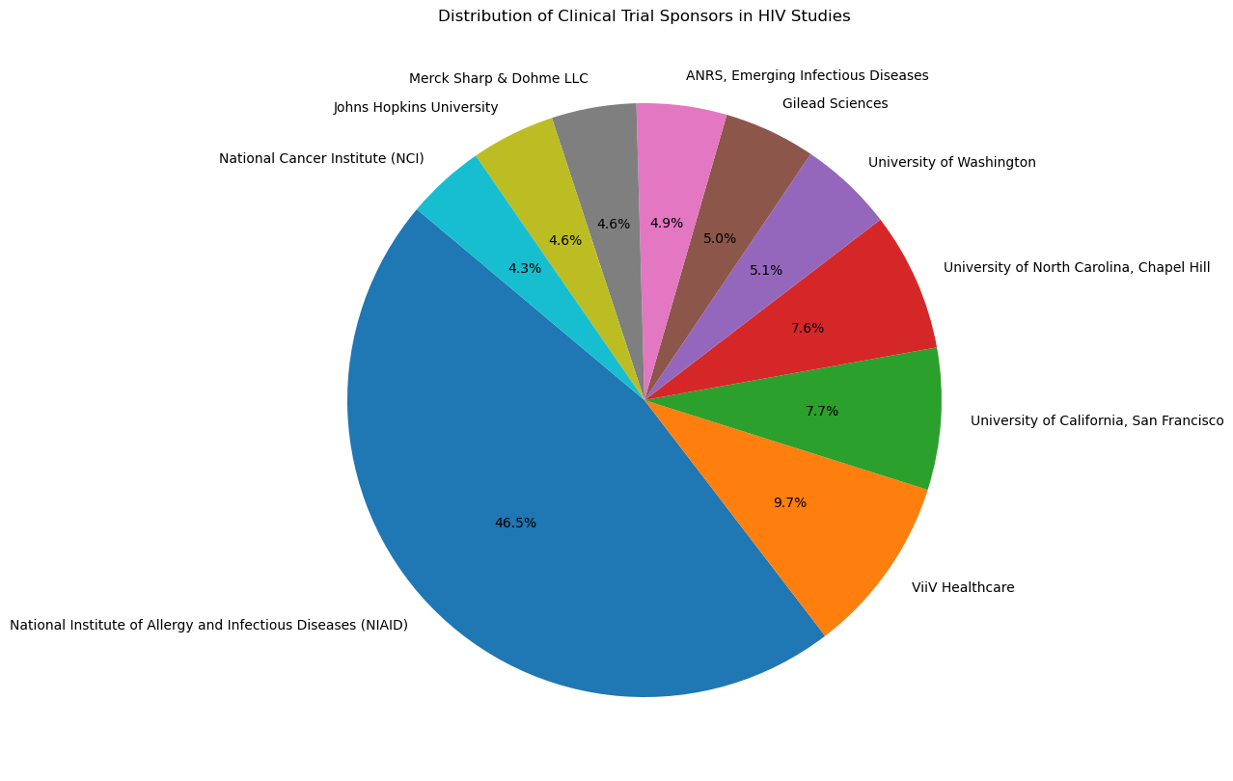

**National Institute of Mental Health (NIMH)**: NIMH has sponsored 503 studies related to HIV. They play a crucial role in supporting mental health and HIV research.

**National Institute on Drug Abuse (NIDA)**: NIDA has sponsored 396 studies, focusing on research related to drug abuse and its connection to HIV.

**National Institute of Allergy and Infectious Diseases (NIAID)**: NIAID has sponsored 366 studies, highlighting its commitment to infectious diseases research, including HIV.

**Eunice Kennedy Shriver National Institute of Child Health and Human Development (NICHD)**: NICHD has sponsored 268 studies, focusing on child health and development, which can intersect with HIV research.

**Merck Sharp & Dohme LLC**: Merck Sharp & Dohme has sponsored 189 studies, reflecting its involvement in pharmaceutical research, including HIV-related studies.

**GlaxoSmithKline**: GlaxoSmithKline has sponsored 179 studies in the dataset, showcasing its contributions to HIV research.

**Gilead Sciences**: Gilead Sciences has sponsored 164 studies. The company is known for its antiretroviral medications used in HIV treatment.

**National Institutes of Health (NIH)**: NIH has sponsored 145 studies, highlighting its broad support for health and medical research.

**National Cancer Institute (NCI)**: NCI has sponsored 127 studies, indicating its involvement in cancer and HIV research.

**ViiV Healthcare**: ViiV Healthcare has sponsored 101 studies, focusing on HIV treatment and research.

These sponsors represent a mix of government agencies, pharmaceutical companies, and institutions. Their sponsorship is crucial for advancing research and treatment related to HIV infections and associated health issues.

- **Pneumonia Sponsorship Analysis**

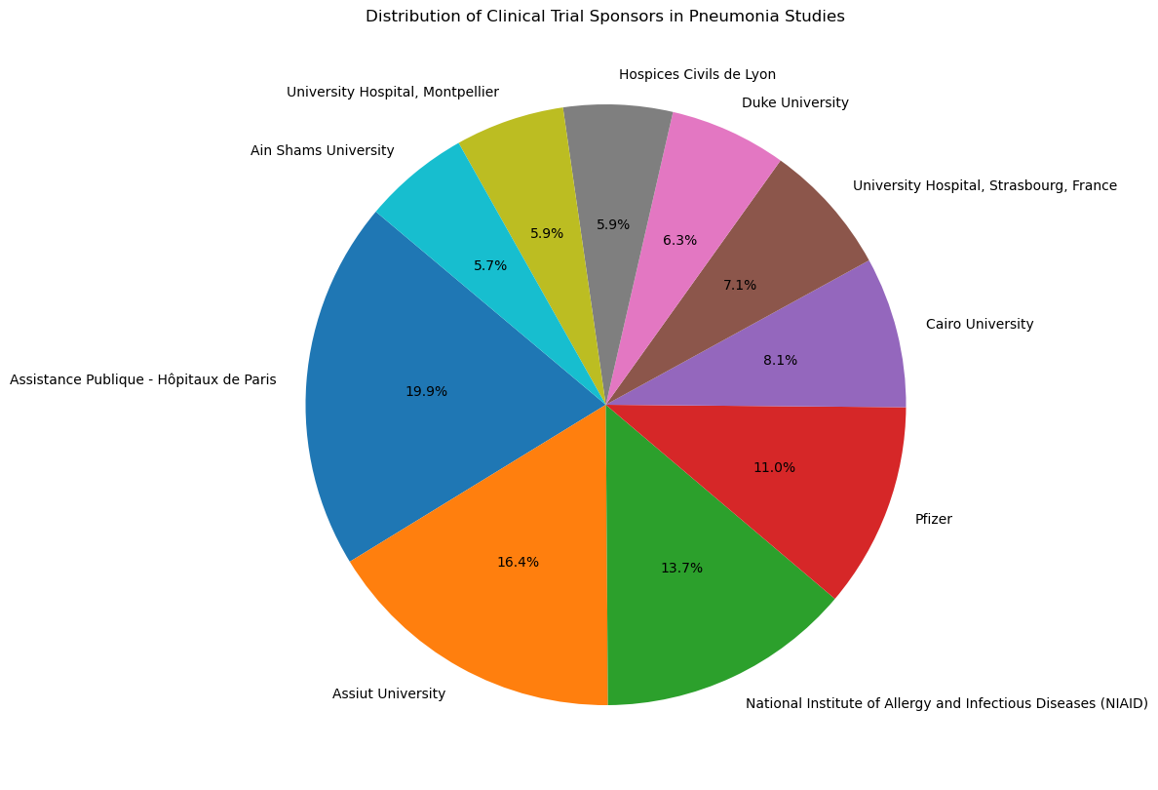

**Assistance Publique - Hôpitaux de Paris (142 studies)**: This sponsor is associated with hospitals in Paris, France, and is actively supporting research related to pneumonia. The organization likely plays a significant role in funding and facilitating pneumonia studies.

**Assiut University (117 studies)**: Assiut University, located in Assiut, Egypt, is actively involved in sponsoring pneumonia research. It is contributing to the advancement of knowledge in this field.

**National Institute of Allergy and Infectious Diseases (NIAID) (98 studies)**: NIAID, a part of the National Institutes of Health (NIH) in the United States, is known for its role in supporting research related to infectious diseases, including pneumonia.

**Pfizer (79 studies)**: Pfizer, a global pharmaceutical company, is actively involved in funding and sponsoring pneumonia-related research. This involvement may include clinical trials for pneumonia treatments and interventions.

**Cairo University (58 studies)**: Cairo University in Egypt is actively supporting and sponsoring pneumonia research. It likely plays a significant role in advancing knowledge in the field within the Egyptian context.

**University Hospital, Strasbourg, France (51 studies)**: This university hospital in Strasbourg, France, is a key sponsor of pneumonia research. It contributes to both clinical and academic aspects of pneumonia studies.

**Duke University (45 studies)**: Duke University in the United States is involved in sponsoring research related to pneumonia. This institution likely conducts research and clinical trials in this area.

**Hospices Civils de Lyon (42 studies)**: Hospices Civils de Lyon, a group of public hospitals in Lyon, France, is actively supporting and sponsoring pneumonia studies.

**University Hospital, Montpellier (42 studies)**: The university hospital in Montpellier, France, is playing a significant role in funding pneumonia research, likely contributing to the academic and clinical understanding of pneumonia.

**Ain Shams University (41 studies)**: Ain Shams University, located in Cairo, Egypt, is actively involved in sponsoring pneumonia research. It is advancing research in the field within the Egyptian context.

These results highlight the international collaboration and support from various institutions and organizations in advancing pneumonia research. They represent a diverse group of sponsors with a shared interest in improving our understanding and treatment of pneumonia, which is crucial for public health.

**- Cancer Sponsorship Analysis**

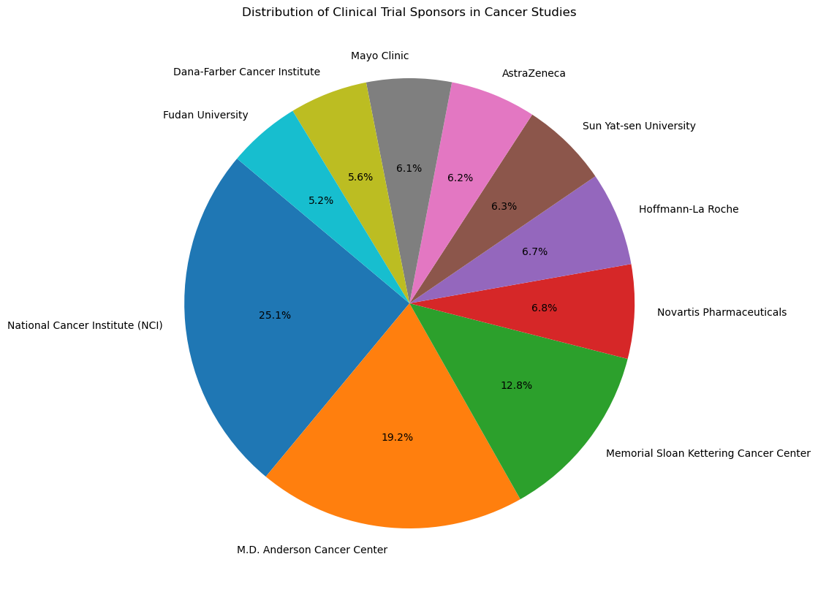

1. **National Cancer Institute (NCI)**: NCI is a leading sponsor in cancer research, known for funding and conducting research to prevent, detect, and treat cancer. Its extensive contributions are crucial to advancing our understanding of cancer.

2. **M.D. Anderson Cancer Center**: This renowned cancer center is actively involved in both clinical and research activities related to cancer. Their sponsorship signifies a commitment to innovative cancer research and patient care.

3. **Memorial Sloan Kettering Cancer Center**: A world-class institution, Memorial Sloan Kettering Cancer Center is committed to cancer research, patient care, and education. Their sponsorship demonstrates their dedication to improving cancer treatments.

4. **Novartis Pharmaceuticals**: Novartis, a major pharmaceutical company, plays a significant role in funding cancer research and developing new cancer drugs and therapies.

5. **Hoffmann-La Roche**: As a global healthcare company, Hoffmann-La Roche invests in cancer research and drug development, contributing to advancements in cancer treatment.

6. **Sun Yat-sen University**: An academic institution involved in cancer research, their sponsorship reflects their active engagement in exploring cancer-related subjects and advancing knowledge in the field.

7**. AstraZeneca**: AstraZeneca, a multinational pharmaceutical company, invests in research for innovative cancer treatments and therapies, aiming to improve cancer patients' lives.

8. **Mayo Clinic**: Known for its patient-centered care, Mayo Clinic is also committed to cancer research. Their sponsorship underscores their dual role in patient care and research advancement.

9. **Dana-Farber Cancer Institute**: This renowned cancer research center is dedicated to finding new cancer treatments and understanding the biology of cancer. Their sponsorship supports ongoing research efforts.

These sponsors represent a diverse group of organizations contributing to cancer research. Their support and contributions are essential in the ongoing battle against cancer, aiming to improve patient outcomes and overall public health.

#### CONDITIONS

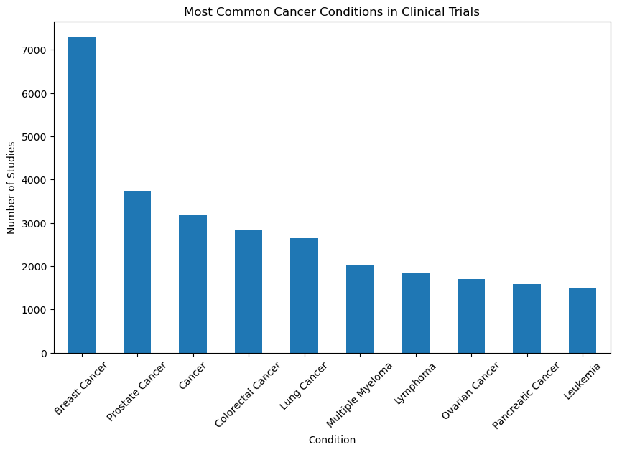

1. **Breast Cancer (7,290):** Breast cancer is the most common cancer among women. It occurs when cells in the breast begin to grow uncontrollably. Early detection and treatment are essential in improving the prognosis of patients with breast cancer.

2. **Prostate Cancer (3,743)**: Prostate cancer primarily affects men and develops in the prostate gland. It is one of the most common cancers among men, and early detection is crucial for successful treatment.

3. **Cancer (3,194**): This general category includes studies that focus on various types of cancers or cancer research in a broader sense.

4. **Colorectal Cancer (2,830):** Colorectal cancer, including colon and rectal cancer, affects the colon or rectum and is one of the leading causes of cancer-related deaths worldwide. Early screening can significantly reduce the mortality rate.

5. **Lung Cancer (2,644**): Lung cancer is associated with the uncontrolled growth of abnormal cells in the lungs. It is often linked to smoking and is the leading cause of cancer-related deaths.

6. **Multiple Myeloma (2,027**): Multiple myeloma is a cancer that affects plasma cells in the bone marrow. It is a relatively rare cancer but can be aggressive.

7. **Lymphoma (1,860**): Lymphoma is a cancer that originates in the lymphatic system, which is part of the immune system. There are various types of lymphomas, including Hodgkin's lymphoma and non-Hodgkin lymphoma.

8. **Ovarian Cancer (1,696**): Ovarian cancer affects the ovaries and is known for its late-stage diagnosis. Early detection and effective treatment are essential for improving outcomes.

9. **Pancreatic Cancer (1,585**): Pancreatic cancer starts in the pancreas and is often diagnosed at an advanced stage. It is known for its aggressive nature and poor survival rates.

10**. Leukemia (1,509)**: Leukemia is a cancer of the blood and bone marrow, resulting in the overproduction of white blood cells. It is divided into several types, including acute and chronic forms.

These findings highlight the importance of ongoing research and clinical studies in understanding, preventing, and treating various cancer conditions. Early detection, awareness, and advancements in treatment options are critical in the fight against cancer.

* **Heart Disease most common Conditions**

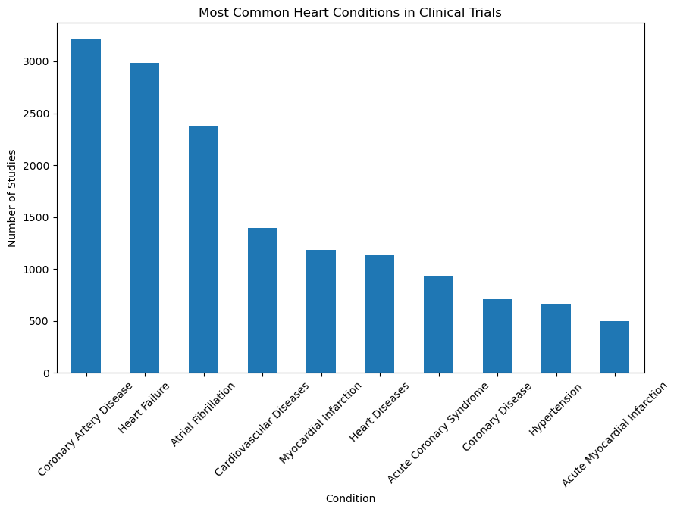

1. **Coronary Artery Disease**: This is the most frequently studied heart condition, with 3,209 clinical trials. Coronary artery disease involves the narrowing or blockage of the coronary arteries, often leading to reduced blood flow to the heart muscle.
2. **Heart Failure**: Heart failure is the second most studied condition, with 2,983 trials. It's a common heart condition where the heart is unable to pump blood effectively, leading to symptoms like shortness of breath and fatigue.
3. **Atrial Fibrillation**: Atrial fibrillation is the third most studied condition, with 2,375 trials. It's a heart rhythm disorder characterized by irregular and often rapid heartbeats.
4. **Cardiovascular Diseases**: This broader category includes various heart and blood vessel-related conditions and is studied in 1,393 trials.
5. **Myocardial Infarction**: Myocardial infarction, or heart attack, is the focus of 1,181 trials. It occurs when there is a lack of blood supply to the heart muscle, leading to tissue damage.
6. **Heart Diseases**: This general category is studied in 1,135 trials and encompasses a wide range of heart-related conditions.
7. **Acute Coronary Syndrome**: This condition, which includes unstable angina and non-ST-segment elevation myocardial infarction, is the focus of 927 trials.
8. **Coronary Disease**: This condition, which may refer to various heart diseases, is studied in 710 trials.
9. **Hypertension**: High blood pressure (hypertension) is the focus of 658 trials. It's a significant risk factor for heart disease.

### Interpretation:

The top 10 heart conditions being studied in clinical trials reflect the diverse range of cardiovascular health issues that researchers and healthcare professionals are actively investigating. These studies aim to improve our understanding of heart diseases, their treatment, prevention, and management. The prevalence of clinical trials in these areas underscores the ongoing efforts to address and find effective solutions for various heart-related conditions that affect individuals' health and well-being.

#### STUDY TYPE AND DESIGN

This analysis assesses the distribution of study types and designs across different diseases, providing valuable information about the research methodologies employed.

* **Pneumonia Studies Study Type**

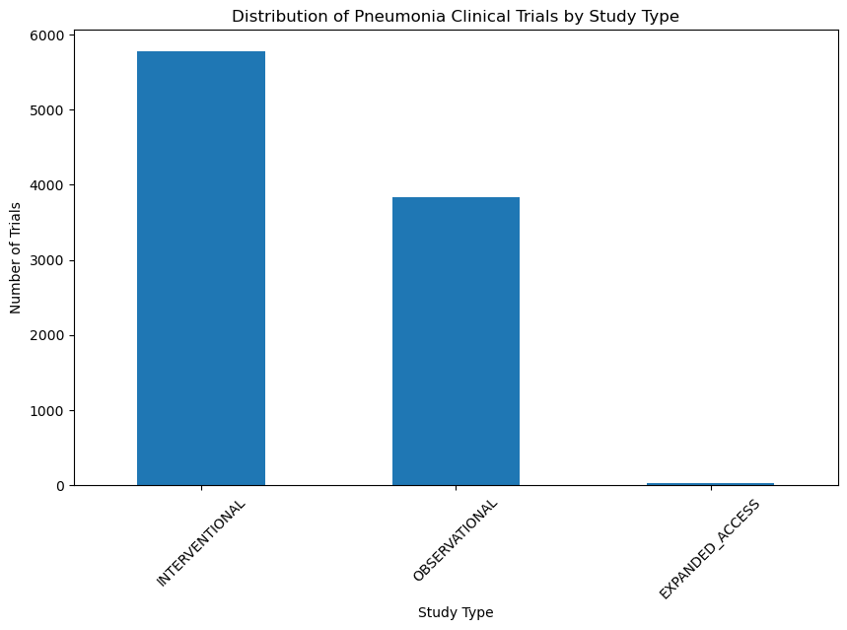

**INTERVENTIONAL**: There are 5,773 studies categorized as interventional. These studies likely involve clinical trials, experiments, or interventions to test specific treatments, drugs, or medical procedures for pneumonia and related conditions.

**OBSERVATIONAL**: There are 3,833 studies categorized as observational. Observational studies typically involve the collection and analysis of data without direct intervention. These studies aim to understand patterns, risk factors, and outcomes associated with pneumonia and related diseases through observation.

**EXPANDED_ACCESS**: There are 34 studies categorized as expanded access. Expanded access programs may allow patients to access investigational treatments outside of clinical trials. This suggests that some studies focus on providing access to new treatments for pneumonia.

* **Covid-19 Clinical Trials by Study Type**

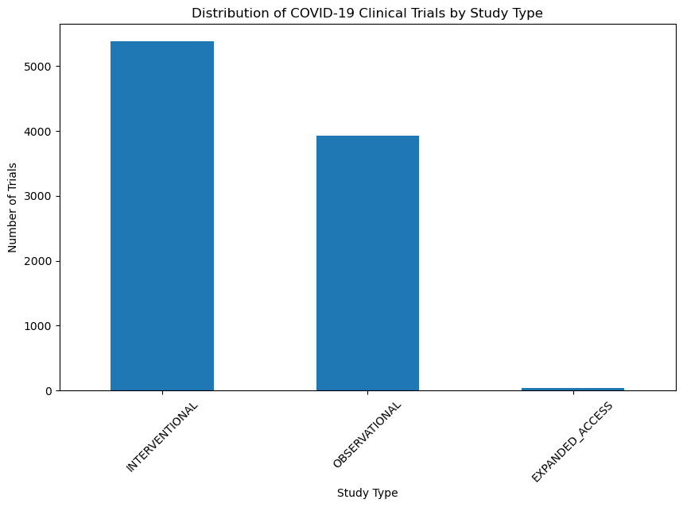

This analysis demonstrates the diversity of study types and designs in COVID-19 research, reflecting the comprehensive approach to combating the pandemic. Researchers are exploring various avenues, from experimental treatments to observational data analysis and compassionate use of experimental therapies.

## Analysis:

* **INTERVENTIONAL (5377)**: The majority of COVID-19 clinical trials fall under the "INTERVENTIONAL" category, indicating a significant focus on trials involving experimental treatments, interventions, and therapies. This emphasizes the extensive efforts to develop and test potential COVID-19 treatments and vaccines.
* **OBSERVATIONAL (3928)**: "OBSERVATIONAL" trials represent a substantial portion of COVID-19 research. These trials involve the collection and analysis of data from participants without intervening in their treatment. Observational studies are important for understanding the natural course of the disease and identifying potential risk factors.
* **EXPANDED_ACCESS (37)**: "EXPANDED_ACCESS" trials are less common, indicating a limited focus on providing experimental treatments to patients who do not qualify for traditional clinical trials. These trials may serve as a means to offer promising treatments to individuals with severe COVID-19 cases.

## Interpretation:

The analysis of study types and designs in COVID-19 clinical trials provides insights into the research approach:

* The prevalence of "**INTERVENTIONAL**" trials underscores the urgency and intensity of efforts to develop effective treatments and vaccines for COVID-19.
* **"OBSERVATIONAL**" trials play a crucial role in understanding the disease's progression, identifying risk factors, and assessing the impact of interventions without experimental interference.
* The presence of "**EXPANDED_ACCESS**" trials indicates a willingness to offer experimental treatments to individuals who may not meet the criteria for traditional clinical trials, potentially providing access to potentially life-saving therapies.
* **HIV Studies Study Type**

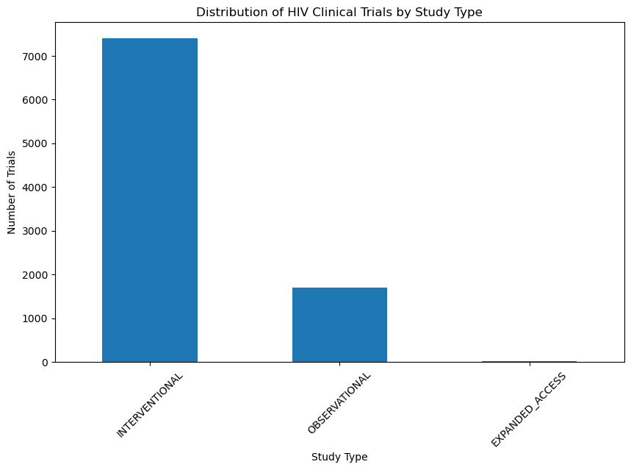

**INTERVENTIONAL (7398 studies)**: These studies involve interventions, such as clinical trials for testing new drugs, therapies, or medical approaches related to HIV prevention, treatment, or management.

**OBSERVATIONAL (1695 studies)**: Observational studies in HIV research focus on collecting and analyzing data without intervening directly with the subjects. These studies are critical for understanding the natural history, epidemiology, and long-term effects of HIV and AIDS.

**EXPANDED_ACCESS (20 studies)**: Expanded access studies typically offer investigational treatments to patients with a severe or life-threatening condition when no comparable or satisfactory alternative treatment is available. In the context of HIV, these studies might provide access to experimental drugs or therapies.

The prevalence of INTERVENTIONAL studies highlights the ongoing efforts to develop new and more effective treatments and interventions for HIV. OBSERVATIONAL studies also play a crucial role in understanding the long-term implications of HIV and AIDS and evaluating real-world outcomes. The presence of EXPANDED_ACCESS studies indicates the importance of providing potentially life-saving treatments to those in need.

* **The Heart Studies Study Type**

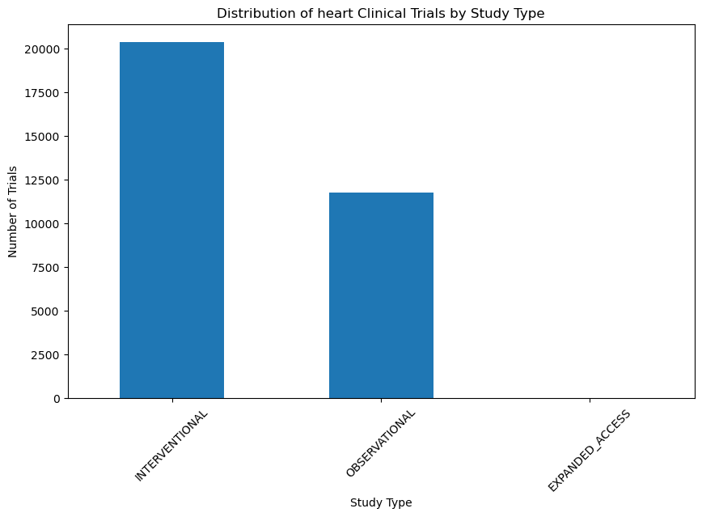

1. **INTERVENTIONAL (20366)**: This study type typically involves active interventions, such as clinical trials and experiments, to assess the effectiveness of treatments, medications, or procedures for heart diseases. It focuses on the impact of interventions on patients' health outcomes.

2. **OBSERVATIONAL (11784)**: Observational studies are designed to observe and analyze the relationships and associations between various factors and heart diseases without directly intervening or altering the subjects' conditions. They are valuable for identifying risk factors and trends.

3. **EXPANDED_ACCESS (26)**: Expanded access studies are typically conducted to provide investigational treatments, such as experimental medications or therapies, to patients with serious or life-threatening heart conditions who cannot participate in clinical trials. These studies allow broader access to potential treatments.

These study types play crucial roles in advancing our understanding of heart diseases and developing improved prevention and treatment strategies. Interventional studies help determine the efficacy of specific interventions, while observational studies provide valuable insights into the factors and trends associated with heart diseases. Expanded access studies provide hope for patients with limited treatment options by offering access to experimental therapies. The combination of these study types contributes to comprehensive research in the field of heart diseases.

* **Malaria Studies Study Type**

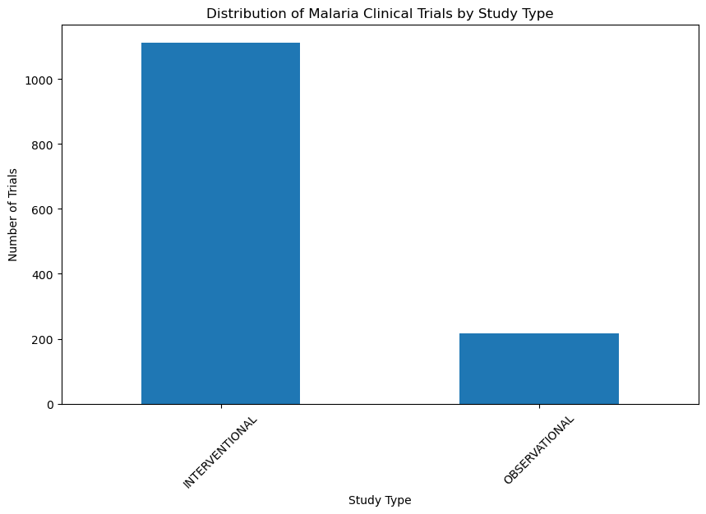

**INTERVENTIONAL (1113 studies)**: The majority of studies in the dataset fall under the "INTERVENTIONAL" category. Interventional studies typically involve experiments or clinical trials where researchers actively intervene to assess the impact of a treatment, drug, or other interventions on participants. In the context of malaria research, this could include testing new drugs, vaccines, or treatment strategies.

**OBSERVATIONAL (217 studies)**: The "OBSERVATIONAL" category represents a smaller but still significant portion of the studies. Observational studies involve the collection and analysis of data without any direct intervention. Researchers observe and analyze participants' health and behaviours, often to better understand the natural course of a disease, risk factors, or outcomes. In the context of malaria, this might involve epidemiological studies, cohort studies, or surveys to understand patterns of infection and disease progression.

### Interpretation:

The dataset contains a **significant number of interventional studies**, indicating a focus on testing and evaluating treatments or interventions for malaria. These studies are likely aimed at developing new therapies or improving existing ones. The presence of observational studies suggests a complementary approach to gather valuable data on the natural history and epidemiology of malaria, which can inform the design of interventions and public health strategies. Both types of studies play crucial roles in advancing our understanding of malaria and improving its management.

* **Cancer Studies Study Type**

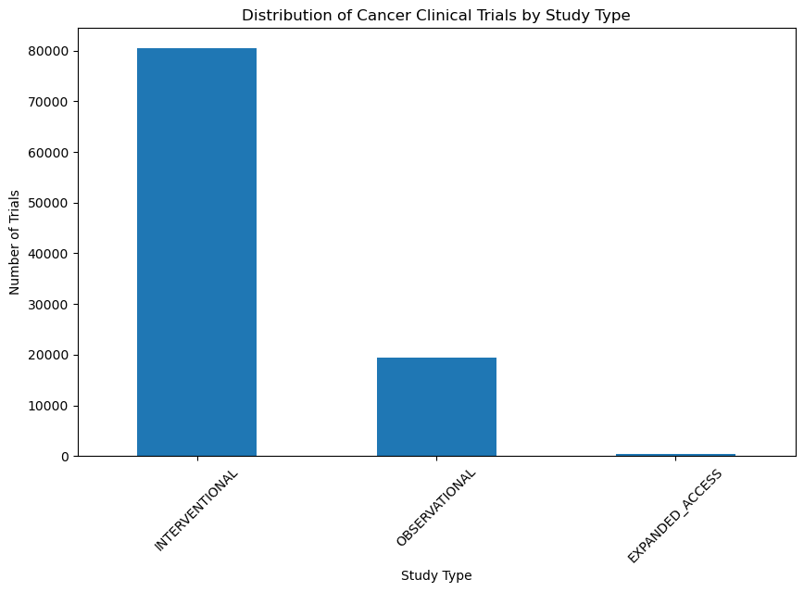

1. **INTERVENTIONAL (80,441**): This study type primarily focuses on active interventions, such as clinical trials, to assess the efficacy of various treatments, drugs, or procedures for cancer patients. It involves controlled experiments to determine the impact of these interventions on patient outcomes and aims to advance cancer treatment and management.

2**. OBSERVATIONAL (19,439)**: Observational studies in cancer research are designed to observe and analyze relationships, trends, and associations between different factors and cancer development, progression, or outcomes. These studies do not directly intervene in the subjects' conditions but provide valuable insights into the natural history of cancer and potential risk factors.

3. **EXPANDED_ACCESS (382):** Expanded access studies in cancer research are conducted to provide access to investigational treatments, typically experimental drugs or therapies, to patients with severe or life-threatening cancer who may not meet the criteria for participation in standard clinical trials. These studies aim to offer potentially beneficial treatments to patients when no other options are available.

Cancer research is a multidisciplinary field where interventional studies play a crucial role in testing new therapies and treatment modalities. Observational studies help in understanding the complex nature of cancer, including its causes and progression, while expanded access studies provide hope to patients with limited treatment options. The combined efforts of these study types are essential in the fight against cancer, leading to improved prevention, early detection, and treatment strategies.

#### FUNDER TYPE ANALYSIS

This section examines the types of funders supporting clinical research, offering insights into the financial backing behind disease-specific studies.

* **Pneumonia Studies Funder Types**

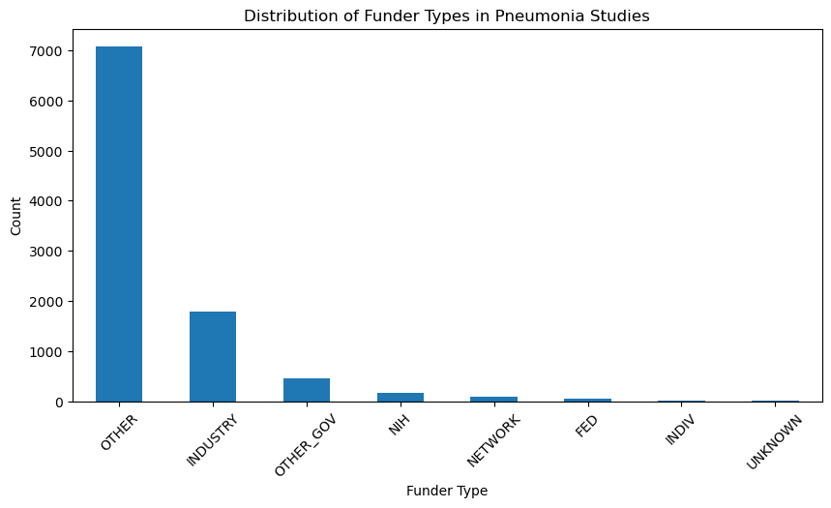

**OTHER**: There are 7,072 studies funded by various sources classified as "OTHER." These sources might include non-profit organizations, foundations, or non-governmental entities.

**INDUSTRY**: There are 1,795 studies funded by the industry. This typically includes pharmaceutical companies or private-sector organizations.

**OTHER_GOV**: There are 453 studies funded by other government agencies.

**NIH**: There are 163 studies funded by the National Institutes of Health (NIH), which is a major research agency in the United States.

**NETWORK**: There are 96 studies with funding from a network of organizations or institutions.

**FED**: There are 47 studies funded by the federal government.

**INDIV**: There are 7 studies funded by individual sources.

**UNKNOWN**: There are 7 studies with unspecified or unknown funding sources.

* **HIV studies Funding Types**

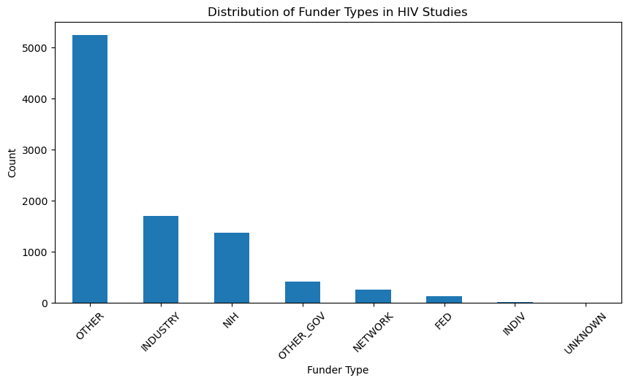

**OTHER (5247 studies)**: The largest proportion of studies in the dataset are funded by sources categorized as "OTHER." This category could include a wide range of funding organizations, such as **foundations, non-profits, or smaller research institutions**.

**INDUSTRY (1696 studies)**: Many studies receive funding from **pharmaceutical and biotechnology companies** or other industries involved in HIV research. Industry-funded studies are often related to drug development or clinical trials.

**NIH (1370 studies)**: The **National Institutes of Health** (NIH) is a significant contributor to HIV research, supporting a substantial number of studies in the dataset. NIH funding often includes a variety of research areas related to HIV and AIDS.

**OTHER_GOV (407 studies)**: This category encompasses studies funded by other government agencies apart from the NIH. These agencies may include **state or local government entities** with an interest in HIV research.

**NETWORK (254 studies)**: Some studies receive funding from **research networks or consortia** dedicated to HIV research. These networks often involve collaboration among multiple institutions or organizations.

**FED (121 studies)**: A smaller number of studies are funded by **federal government sources outside of the NIH**. These studies may have specific purposes or focus areas related to HIV research.

**INDIV (16 studies)**: A small proportion of studies are individually funded. These might include research projects led by **individual researchers or principal investigators**.

**UNKNOWN (2 studies)**: A minimal number of studies have unidentified or unclassified funding sources.

### Interpretation

The distribution of funding sources underscores the diverse range of organizations and institutions involved in funding HIV research, reflecting the importance of collaborative efforts in addressing this public health issue. The substantial representation of "OTHER" suggests the involvement of various non-governmental and non-industry entities in supporting HIV-related studies. It's essential to continue this multidisciplinary approach to advance our understanding of HIV and develop effective interventions and treatments.

* **Heart Studies Funding Types**

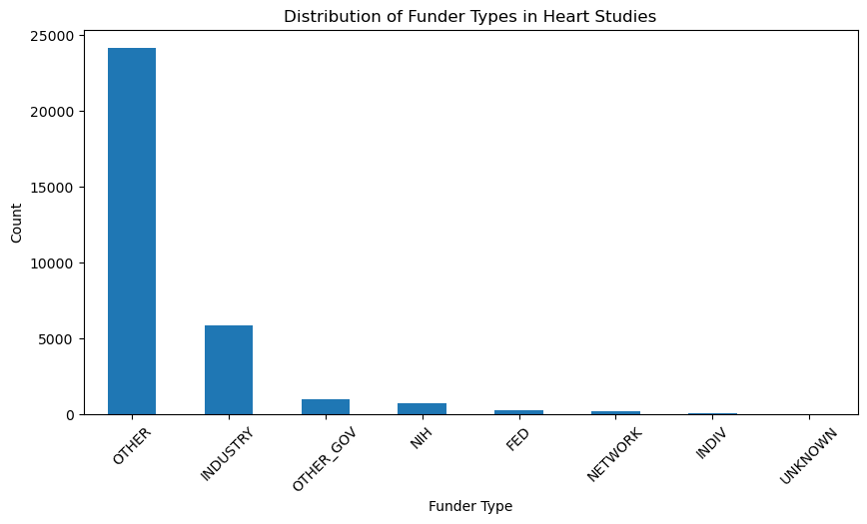

**OTHER**: The majority of the studies (24,118) have funding from sources categorized as "OTHER." This category likely includes a wide range of funding entities, such as private foundations, non-profit organizations, or international agencies.

**INDUSTRY**: There are 5,856 studies funded by the industry, which typically includes pharmaceutical and biotechnology companies. Industry-funded studies often aim to develop new drugs or treatments.

**OTHER_GOV**: A notable number of studies (1,003) receive funding from other government agencies not explicitly categorized as "FED" (Federal) or "NIH" (National Institutes of Health).

**NIH (National Institutes of Health)**: The National Institutes of Health is a significant funding source for heart studies, with 726 studies receiving funding from this federal agency.

**FED (Federal):** Federal funding, apart from the NIH, is also contributing to the funding of 232 studies. These funds may come from various government departments or agencies.

**NETWORK**: There are 205 studies funded by networks or collaborations of institutions, which may include multiple universities, research centres, or healthcare organizations.

**INDIV (Individual):** A relatively small number of studies (31) receive funding from individual sources, such as philanthropists or private donors.

**UNKNOWN**: In a few cases (5), the specific funder type is categorized as "UNKNOWN." This category might represent instances where the funding source is not clearly defined or reported.

### Interpretation:

The distribution of funder types reflects the diverse sources of funding for heart studies. The "OTHER" category is the most prevalent, indicating the involvement of a wide range of non-governmental and non-industry entities in funding heart research. Industry and government (including NIH and other government agencies) are also significant contributors, highlighting their role in supporting cardiovascular research.

The presence of "NETWORK" and "INDIV" categories underscores the collaborative nature of research, with studies funded by multiple institutions or individual donors. Additionally, the "UNKNOWN" category suggests the need for more precise reporting of funding sources in certain cases.

* **Malaria Funding Types**

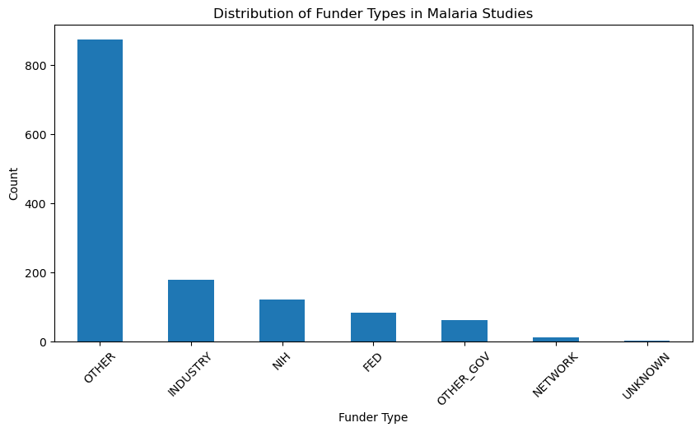

**OTHER (874 studies)**: The majority of malaria studies in the dataset are funded by sources categorized as "OTHER." This category likely includes a wide range of funding entities, such as **private foundations, non-profit organizations, and potentially other government agencies** not explicitly listed in the specific categories.

**INDUSTRY (178 studies)**: A significant number of studies are funded by the industry, which may include **pharmaceutical companies, biotech firms, or other private sector entities**. Industry funding often supports clinical trials and the development of new treatments.

**NIH (120 studies)**: The **National Institutes of Health (NIH) is a prominent source** of funding for malaria research. It is a U.S. government agency dedicated to supporting and conducting biomedical and health-related research.

**FED (83 studies)**: "FED" likely represents studies funded by various federal agencies. This could include agencies within the **U.S. federal government or potentially other countries' government agencies**.

**OTHER_GOV (62 studies)**: "OTHER_GOV" signifies studies funded by government agencies other than the NIH or those categorized as "FED." These could be **international or regional government entities**.

**NETWORK (12 studies)**: The "NETWORK" category may include studies that are part of larger research networks or consortiums with their own funding sources.

**UNKNOWN (1 study)**: There is one study with an unknown or unspecified funding source.

### Interpretation:

The dataset reflects a diverse range of funding sources for malaria studies, with the **majority falling into the "OTHER" category**. This diversity suggests a collaborative and multifaceted approach to funding malaria research, involving both government agencies and private sector organizations. It's important to note that funding sources can influence the scope, objectives, and focus of studies, and understanding these sources can provide insights into the landscape of malaria research funding.

* **Covid-19 Funding Types**

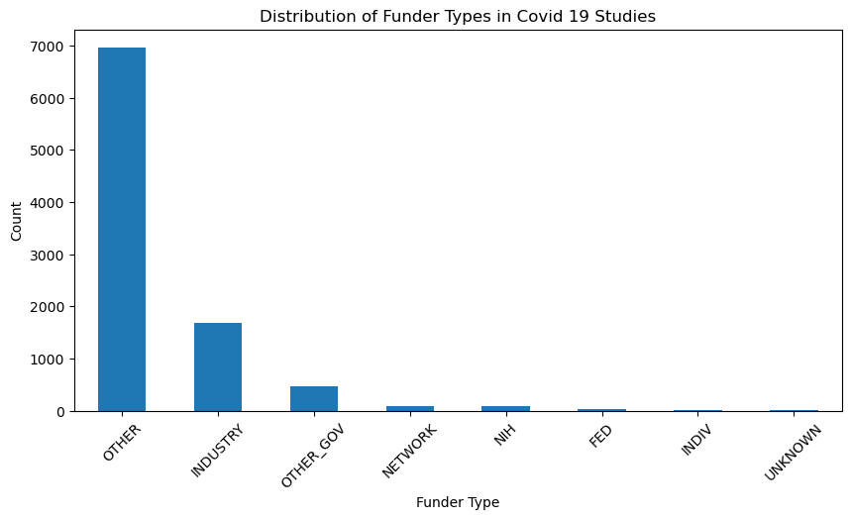

In the context of our clinical data on COVID-19 studies, "funder type" refers to the category or classification of organizations or entities that provide financial support for these studies. Here's an interpretation of the different funder types based on our provided data:

1**. Other:** The category "Other" is the most prevalent funder type, with 6,955 COVID-19 studies falling into this category. This may include a diverse range of funders that are not specifically categorized elsewhere, such as private foundations, non-profit organizations, or international entities.

2. **Industry**: The "Industry" funder type is associated with 1,680 COVID-19 studies. This category typically includes pharmaceutical companies, biotechnology firms, and other private sector entities that invest in research and development related to COVID-19 treatments, vaccines, and diagnostics.

3. **Other Government (OTHER_GOV):** There are 469 COVID-19 studies funded by "Other Government" entities, which could include various national or international government bodies other than the U.S. National Institutes of Health (NIH).

4. **Network**: "Network" is associated with 97 COVID-19 studies. This category may refer to research networks or collaborations involving multiple organizations or institutions working together on COVID-19 studies.

5. **NIH (National Institutes of Health)**: The U.S. NIH, a prominent research agency, is listed as the funder in 95 COVID-19 studies. The NIH plays a significant role in supporting medical and scientific research, including studies related to COVID-19.

6. **Federal (FED):** "Federal" funders, which represent the U.S. federal government or its agencies other than the NIH, have supported 31 COVID-19 studies.

7**. Individual (INDIV):** This category includes 8 COVID-19 studies funded by individual contributors or donors.

8. **Unknown**: The "Unknown" category consists of 7 COVID-19 studies where the funder type is not specified or is not clear from the available data.

Understanding the various funder types is essential for tracking the sources of financial support and collaboration in COVID-19 research. These funders play a vital role in advancing our knowledge of the virus and developing effective strategies for prevention, treatment, and control.

* **Cancer Funder Types:**

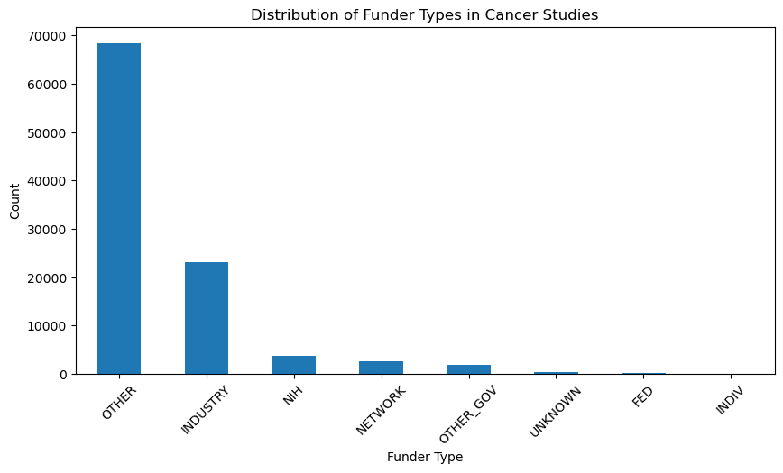

1. **Other**: The "Other" category is the most prevalent funder type in cancer studies, with 68,348 studies falling into this category. This broad category includes various funders that are not specifically categorized elsewhere, such as private foundations, nonprofit organizations, or international entities.

2. **Industry: Th**e "Industry" funder type is associated with 23,107 cancer studies. This category typically includes pharmaceutical companies, biotechnology firms, and other private sector entities that invest in research and development related to cancer treatments, drug development, and diagnostics.

3**. NIH (National Institutes of Health)**: The U.S. National Institutes of Health (NIH) is listed as the funder in 3,774 cancer studies. The NIH is a prominent research agency that provides substantial funding for medical and scientific research, including cancer research.

4. **Network**: "Network" is associated with 2,567 cancer studies. This category may refer to research networks or collaborations involving multiple organizations, institutions, or researchers working together on cancer-related studies.

5. **Other Government (OTHER_GOV)**: There are 1,899 cancer studies funded by "Other Government" entities, which could include various national or international government bodies other than the NIH.

6**. Unknown**: The "Unknown" category consists of 270 cancer studies where the funder type is not specified or is not clear from the available data.

7. **Federal (FED)**: "Federal" funders, which represent the U.S. federal government or its agencies other than the NIH, have supported 243 cancer studies.

8**. Individual (INDIV**): This category includes 54 cancer studies funded by individual contributors or donors.

Understanding the various funder types is essential for tracking the sources of financial support and collaboration in cancer research. These funders play a vital role in advancing our understanding of cancer, improving diagnostics, and developing more effective treatments for cancer patients.

# CONCLUSION

The conclusion summarizes the key findings from the data analysis, highlighting trends and significant insights in each disease category. It discusses the implications of these findings for the medical field and future research directions.

**COVID-19 Studies:**

The research landscape related to COVID-19 has been extensive and dynamic. The temporal analysis showed that studies gained significant **momentum in 2020, peaking with over 4,600 publications.** These studies have primarily been interventional, reflecting the urgent need for treatments and vaccines. Researchers have been funded by various entities, with Assistance Publique - Hôpitaux de Paris and Assiut University being significant sponsors. "Other" and "Industry" have been the predominant funder types.

**Cancer Studies:**

Cancer research continues to thrive with consistent growth in publications. The trend analysis revealed a significant **increase in studies from 2003 onwards, peaking in 2023 with over 7,500 publications**. The "Other" funder type dominates cancer research funding, possibly indicating a diverse range of contributors. "Industry" and "NIH" have also been prominent funders, highlighting collaboration between the private sector and government institutions.

**Pneumonia Studies:**

The analysis of pneumonia studies revealed a surge in publications in 2020, likely driven by the COVID-19 pandemic. The majority of these studies are interventional. The "Other" funder type is prevalent, suggesting a mix of sources supporting research on pneumonia.

**Heart Studies:**

Studies related to heart diseases show consistent growth, with a significant increase in publications since 2015. The most studied heart condition is Coronary Artery Disease, reflecting its global prevalence. These studies are funded by a mix of entities, including the National Heart, Lung, and Blood Institute (NHLBI) and Medtronic.

**Malaria Studies:**

Malaria studies exhibited a fluctuating trend, with an increase in publications in the early 2000s. "INTERVENTIONAL" has been the primary study type, emphasizing the importance of testing treatments and interventions for malaria. The World Health Organization and London School of Hygiene and Tropical Medicine have been notable sponsors.

**HIV Studies:**

HIV studies have shown consistent growth in publications over the years, with a peak in 2018. "ADULT, OLDER_ADULT" and "CHILD, ADULT, OLDER_ADULT" study populations are widely represented. The National Institute of Mental Health (NIMH) and National Institute on Drug Abuse (NIDA) have been significant sponsors.

In conclusion, these analyses highlight the dynamic nature of medical research, with each area of study exhibiting unique trends and patterns. Research on COVID-19, cancer, pneumonia, heart diseases, malaria, and HIV has been multifaceted, involving diverse funders and collaboration networks. These findings provide valuable insights for future research, funding allocation, and decision-making in healthcare and medical research.

# RECOMMENDATIONS

This section offers recommendations for future research and clinical trials, based on the insights obtained from the data analysis.

1**. Interdisciplinary Collaboration:** Encourage interdisciplinary collaboration among researchers, as complex health challenges often require a multi-faceted approach. This is especially relevant in the context of diseases like COVID-19 and cancer, where the research landscape is extensive and diverse.

2**. Continual Investment:** Sustain and increase investment in research for infectious diseases like COVID-19, HIV, and malaria. These diseases remain global health threats, and well-funded research is critical for developing treatments and preventive measures.

3. **Funder Diversity:** Foster diversity in funding sources. Diverse funding streams help ensure a broader range of research topics are explored and reduce dependence on any single source.

4**. Targeted Research**: Allocate resources for targeted research in areas with a significant increase in publications, such as COVID-19 in 2020 and cancer studies in recent years.

5. **Public Health Preparedness**: Emphasize public health preparedness and the importance of investing in research and infrastructure to address pandemics like COVID-19. Develop strategies for rapid research mobilization during health crises.

6. **Research Accessibility**: Promote open-access research to make findings easily accessible to the global scientific community. This is particularly important for diseases with a high global impact, such as COVID-19 and HIV.

7. **Data Analysis Tools**: Develop advanced data analysis tools and methodologies to handle the increasing volume of research data. This will aid in more effective analysis and interpretation.

8. **Clinical Study Diversity**: Encourage diversity in clinical studies, considering various populations, including adults, children, and older adults. This is especially important in HIV research, where age groups vary significantly.

9. **Monitoring Trends**: Continually monitor research trends and funding patterns to stay informed about emerging diseases and the evolving research landscape.

10**. Long-term Commitment**: Recognize that research into diseases like cancer, heart conditions, and pneumonia requires long-term commitment, as the benefits of research may not be realized for many years.

11**. Global Collaboration**: Promote global collaboration among researchers, institutions, and nations. Global cooperation is vital in the fight against infectious diseases like COVID-19 and malaria.

12. **Addressing Health Disparities**: Prioritize research efforts to address health disparities and access to healthcare, especially in underrepresented populations. This is crucial in addressing diseases like HIV and heart conditions.

These recommendations are intended to guide policymakers, funding agencies, and researchers in making informed decisions about research priorities, funding allocation, and collaborative efforts to address the pressing health challenges of our time.

# ACKNOWLEDGEMENTS

We wish to express our heartfelt gratitude to the team at DTE Consultancy, in partnership with Moringa School, for entrusting us with the opportunity to conduct this comprehensive research. Their vision, guidance, and support have been instrumental in the successful completion of this project.

We extend our appreciation to all members of our research team; whose dedication and hard work made this analysis possible. Each team member brought unique skills and insights that enriched our research and contributed to the depth of our findings.

We would also like to acknowledge the invaluable contribution of the following organizations; whose data and resources greatly facilitated our research:

- U.S National Library of Medicine

- https://clinicaltrials.gov/

In addition, we extend our gratitude to the numerous individuals and institutions whose publications, data, and expertise were indispensable in our data analysis. Their collective efforts in advancing scientific knowledge have made this research possible.

Finally, we express our deep appreciation to our families, friends, and colleagues for their unwavering support and encouragement throughout this research endeavour. Their belief in our work has been a constant source of motivation.

This research would not have been possible without the collaboration, guidance, and support of these individuals, organizations, and data sources. We acknowledge their invaluable contributions to our research journey.

# REFERENCES

The paper includes a list of references for cited sources and data repositories used in the study.

<https://clinicaltrials.gov/> ------

<https://drive.google.com/drive/folders/1lVOIrFmAmq0R4s_FK4OgQ47KF> ---- data repositories